Bunny Street connection – Options Considered



Purpose of this Document

This document outlines the options considered for developed design for the Bunny Street connection and the TSB Arena laneway safety improvements

Context
Bunny Street is a busy two-way street in front of Wellington Railway Station used by cars, people on bikes and scooters, pedestrians and taxis.
Pedestrian traffic is highest at peak times from 7am -9am and 4pm – 6pm. It is not on a bus route. The Bunny Street Connection across to Lady Elizabeth Lane that we are addressing in this part of the project is 176 metres long. Bunny Street is a major access point for commuters using the railway network and arriving at the station – an average of 9000 – 11000 pedestrians arrive at the station in the morning peak with an estimated 50% of these (4500-5500) exiting via the station forecourt..
The Average Daily Traffic (ADT) in the eastbound direction towards the harbour is relatively low, with only 2957 vehicles per day with the bulk of traffic travelling in the westbound direction (towards Featherston Street), 8304.
Currently we know that around 614 cyclists per weekday use Bunny Street. We expect this number to grow with the recent completion of the Thorndon Quay cycleway and the completion of Te Ara Tupua due in April 2026. Improving this connection and the level of service for people on bikes is also expected to attract a wider range of people on bikes including the less confident riders.

In the past ten years there have been 61 crashes reported to police on Bunny Street. 16 of those crashes involved injury (3 serious injury and 13 minor injury). 10 crashes involved cyclists, and six crashes involved pedestrians

Among the 10 cyclist-involved crashes, six resulted in no injuries, three involved minor injuries, and one led to a serious injury.

We know that crashes tend to be underreported as not all crashes get reported to police.
Year | Non-injury crash | Minor-injury crash | Serious-injury crash | Fatal crash | Totals | Cyclist involved | Pedestrian involved
Totals | 45 | 13 | 3 | 0 | 61 | 10 | 6
Proportions | 74% | 21% | 5% | 0 | 100% | 16% | 10%

Because there is no clear and coherent facility down this street to and from Lady Elizabeth Lane at Waterloo Quay and because stacking cars tend to wait in the cycle lane, there are many different ways that people on bikes move down this street including on the footpath. Having bikes weave between traffic in several different directions means that drivers need to be very aware of people on bikes in multiple places on the street currently.

Options Considered – Summary
Focus | Options | Preferred Option
Bunny Street
Bunny Street Cycleway, intersections and mid-block | Option 1: Do Nothing  Intersections and mid-block
Cycleway options | Option 1: One way protected cycleway each side of road
 | Option 2: Two-way protected cycleway south side
 | Option 3: Two-way protected cycleway north side
Intersection Options for a two-way cycleway | Option 1: Shared space with pedestrians at intersections
 | Option 2: Signal phasing controlling intersection movements – cycleway remains on-road.
Mid-block Pedestrian Options | Option 1 Do Nothing – crossing remains the same (no specific facility provided)
 | Option 2: Raised crossing – zebra across cycleway only/courtesy across vehicle lane
 | Option 3: Raised crossing – courtesy crossing across cycle lane and vehicle lanes with conflict zone red marking
 | Option 4: At Grade Zebra Crossing
Waterfront
 | Option 1: Waterloo and Jervois Quay – on road cycle lanes
 | Option 2: Separated cycle lane along the alternative laneway route
 | Option 3: Improved safety of shared spaces along alternative laneway route particularly at known conflict points

Options Considered – Bunny Street cycleway and intersections:
Option One: Do Nothing
Thorndon Bunny intersection | Waterloo Quay intersection | Mid block
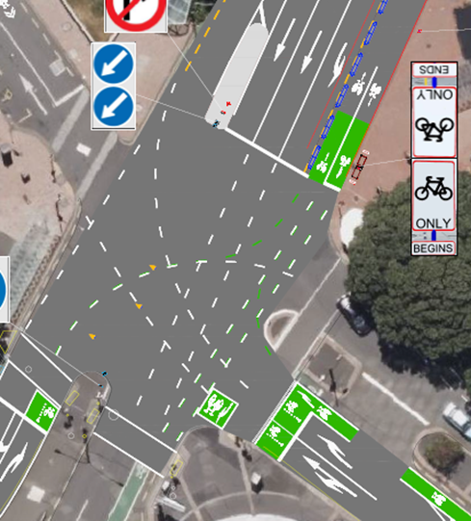 | 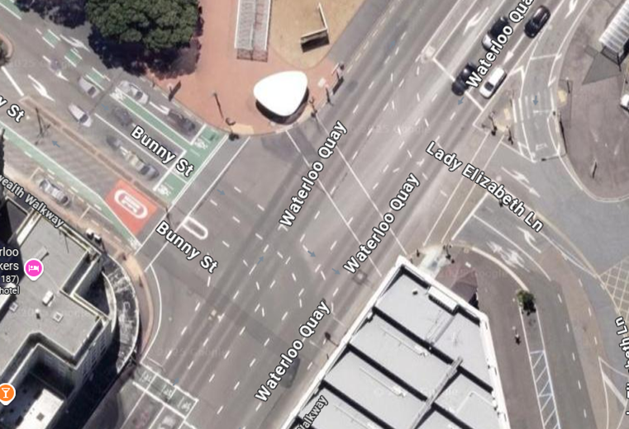 | 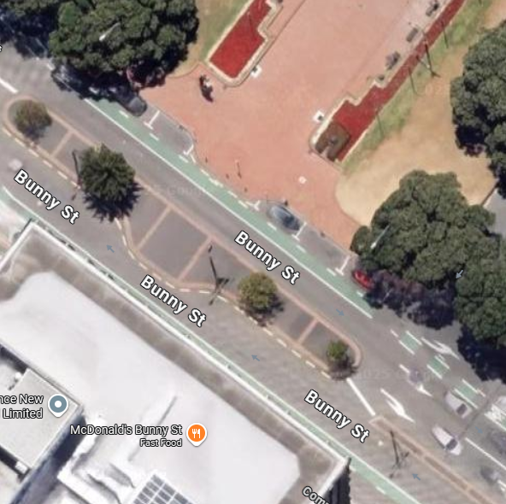
- Painted cycle lanes in both directions on Bunny Street inside parked cars  - Advance stop boxes for bikes  - Right turn into Thorndon Quay cycleway called by push button  - Car parks removed in Bunny Street: 0 | - Painted cycle lane  - Advance stop boxes on Bunny St and Lady Elizabeth Lane  - No facility on the harbour side of the intersection  - Bikes use pedestrian light to cross OR cross on car light to southern side of Bunny Street on a short phase not quite long enough for this move.  - Bikes frequently use footpath through to Featherston OR a strange combination of crossing at the island cut through to the west bound traffic lane.  - An average of 751 pedestrians cross here in the morning peak (7am-9am) and 718 in the evening peak (5pm-7pm). An average of 2844 cross here daily. (Viva City 2025) | - Pedestrian build outs and island but no crossing facility midblock  - Car parks removed in Bunny Street: 0  - High pedestrian volumes, especially in morning and afternoon peak  - Painted cycle lane next to parked cars

Option One Pros | Option One Cons
- Low cost  - No disruption to road users | Featherston/Bunny Intersection  - Continued congestion from light phasing necessary to protect right turning cyclists from Bunny St. into  Thorndon Quay.  - Continued non-compliance of cyclists left turning from Thorndon Quay into Bunny creating Pedestrian  and Vehicle conflict.  Midblock  - Not clear how to get to the Thorndon Quay bike lane from Bunny St East.  - Stacking traffic heading west or turning right into the station often queues over or in cycle lanes meaning  cyclists must weave between cars to get through  - Low level of service for people on bikes - painted cycle lanes do not provide full protection for less confident cyclists – prone to car dooring or vehicles encroaching  - Lack of visibility for people crossing due to food trucks and parked car  Waterloo/Bunny Intersection  - Difficult for less confident cyclists to navigate this intersection from Lady Elizabeth lane – either have to go with the traffic on the green signal across a very long intersection OR go with pedestrians and share the footpath space on the station side of the street.  - Also difficult to navigate intersection in other direction from Bunny Street cycle lane – long cross to traffic lane OR cross onto footpath space where there is not good intervisibility with pedestrians around the corner of the building  - Encourages pedestrian/bike conflict

Cycleway Options - Bunny Street
Option One: One-way protected cycleway either side of road
Option One Pros | Option One cons
- Bikes catered for on both sides of the road  - Caters for those who are confident to ride Jervois Quay and come into Bunny on the left-hand side of the road  - Improves visibility of bikes as parking removed on both sides of road | - Does not provide good connection to Lady Elizabeth Lane across the long intersection – not likely to reduce footpath use from Lady Elizabeth to Thorndon Quay  - Removes the parking on both sides of the road (6 P120 car parks north side, 3 P120 car parks south side, 1 Tour bus stop, 1 loading zone)  - Removes the coach park and shuttle parking used by shuttle providers  - Significant phasing changes needed if protection is extended to intersection for cyclists to access Thorndon Quay.
Option Two: Two-way protected cycleway southern side of road
Option Two Pros | Option Two cons
- Provides most direct route for confident cyclists on the Waterloo Quay to access Thorndon Quay  - Prevalent afternoon flows of pedestrians will cross cycleway at or near Featherston intersection  - Provides most direct access to Bunny st. West with no phasing changes. | - Removes 1 Tour bus park, 1 loading zone and 3 P120 car parks  - Does not provide good connectivity with Thorndon Quay two-way cycleway at Featherston/ Bunny intersection  - Does not provide good connectivity with Lady Elizabeth Lane across long intersection  - Does not provide good connectivity for less confident cyclists who are less likely to be on the Quays  - Requires significant phasing changes to provide protected phase for cyclists to access TQ and will provide low LOS for cyclists.
Option Three: Two-way protected cycleway northern side of road
Option Three Pros | Option Three cons
- Provides good connectivity with Thorndon Quay two-way cycleway  - Allows greater level of service for turning bikes around the corner  - Parking removal improves visibility of pedestrians crossing Bunny to vehicles.  - Provides good connectivity with Lady Elizabeth Lane as it is a shorter distance across the intersection  - Retains coach and shuttle parking on the other side of the road | - Conflict points at high traffic entrances to railway station drive.  - Removes 6 P120 car parks  - Food truck required to relocate into forecourt of station.
Preferred Option
The preferred option is the two- way cycleway on the north side of the road as it has better connectivity with both the Thorndon Quay cycleway and Lady Elizabeth Lane, provides a greater level of service at the Featherston Bunny intersection for bikes and saves one side of parking (for coaches and shuttle in particular). We believe we can mitigate the risk at the station entrances with raised features to slow all users crossing here these.

Intersection Options for two-way protected cycleway
Option One: Two-way cycleway with shared spaces at intersections
Thorndon Bunny intersection |  | Waterloo Quay intersection
- Cycleway ramps up to footpath level  - Cycle ramp to access Thorndon Quay cycleway  - Pedestrians’ cross cycleway to access pedestrian crossing on built out section of footpath.  - Existing phasing with cycle advanced start for Thorndon Quay  - Car parks removed in Bunny Street: 6 |  | - Cycleway ramps up to shared path  - Dual pedestrian and cycle crossing  - Cycle movement controlled by two aspect cycle signal  - Footpath built out on both sides to increase pedestrian and cycle waiting space
Pros | Cons | Pros | Cons
- Minimal delay for cyclists turning right into Thorndon Quay  - No increase in delays for vehicles | - Cyclists cross pedestrians path (waiting area and crossing could be provided)  - Cyclists unable to travel from cycleway to Bunny St west  - Higher cost from civil works  - Resource consent possibly required for changes to forecourt | - Cyclists and pedestrians cross paths at Bunny St which is 15m wide  - Shorter cycle crossing is safer | - Shared space on footpath could increase ped and cycle conflict  - More difficult for cyclists to turn right into Waterloo Quay  - Pedestrian shelter should be relocated - costly  - Increased cost and civil works  - Resource consent possibly required for changes to forecourt

Option Two: Two-way protected cycleway with signal phasing controlling intersection movements
Thorndon Bunny intersection |  | Waterloo Quay intersection
- Two-way cycleway along length of Bunny Street using existing road space  - Additional phase needed to enable cyclists to leave cycleway  - Left turn and straight-ahead cycle movement has more conflicts than right turn and would require own phase  - Potential for directional cycle signals to enable cycle right turn in phase A  - Car parks removed in Bunny Street: 6 |  | - Cycleway ramps up to shared area on harbour side – Path demarcated in this area cycle path for some of area  - Dual pedestrian and cycle crossing  - Cycle movement controlled by two aspect cycle signal
Pros | Cons | Pros | Cons
- Enables cyclists to turn in all directions  - Cyclists and pedestrians have own space  - Limited civil works | - Slight increase in delay for vehicles from additional phase (minor)  - Low level of service for cyclists waiting for cycle phase | - Easier for cyclists to turn right to access Waterloo Quay  - No impact on pedestrian shelter  - Lower cost and less civil works | - Cyclists and pedestrians cross at Lady Elizabeth Lane which has less space and requires kerb buildout  - Longer cycle crossing distance but much better than current situation  - Higher crossing speeds for cyclists
Preferred Option
Option Two is preferred as it minimises pedestrian and cycle conflict in this busy space and has the greatest increase in level of service for bikes at each of the intersections whilst keeping pedestrians protected.

Options considered – Mid block Bunny Street pedestrian crossing
Mid-block options Bunny Street pedestrian crossing
On average between 9000 and 11000 commuters arrive at the station every day in the morning peak and approximately 50% of them (4500-5500) exit through the front doors. Of these, approximately 750 cross Waterloo Quay each day, some will cross Bunny Street at Waterloo Quay but the majority head through the central station forecourt to this central crossing point. Mostly they travel straight across the road but if that space is busy some spread at this point and filter through the traffic over the central island to cross to the other side of Bunny Street and around to Featherston Street.
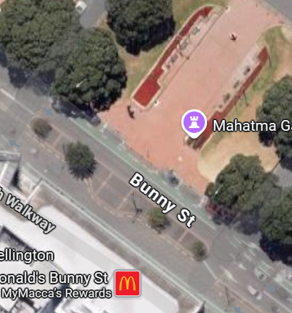
Option One - Do Nothing for midblock crossing – protected 2-way cycleway – crossing remains the same
Pros | Cons
- Current situation where pedestrians give way to cyclists (although they will now need to look both ways) | - If a two-way cycleway is installed with no infrastructure changes for pedestrians there could be an increase in conflict at this busy crossing point particularly with people on bikes coming from two directions which pedestrians do not expect.  - Pedestrians could be crossing the cycleway at any point along it which would make it difficult for people on bikes to navigate.  - There is no increase in level of service for pedestrians in Wellingtons busiest pedestrian street – it may be viewed as a decrease in level of service by the community.

For options two to five below, includes:
- a two-way cycleway on the northern side of the road with a bend in the cycleway to slow speeds on the crossing approach,
- a pedestrian island space between the cycleway and the roadway so that pedestrians do not have to cross both at the same time,
- signage to alert pedestrians to look both ways for the two-way cycleway.
 |  | 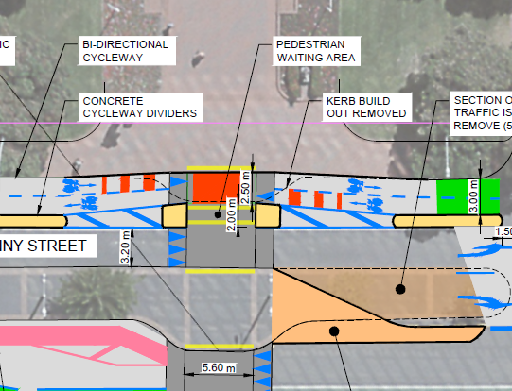
Option Two - Raised Crossing – zebra across two-way cycleway only / courtesy across vehicle lane |  | Option Three - Raised crossing – courtesy crossing across two-way cycleway and vehicle lanes with conflict zone red marking
Pros | Cons | Pros | Cons
- In a high-volume pedestrian street such as this a zebra would provide priority for pedestrians crossing the cycleway | - Could confuse pedestrians if they have a zebra across the cycleway but not the vehicle lane – they may assume they have it in both and step onto the roadway.  - However full zebra not preferred by WCCTOC due to pedestrian volumes and network impacts of pedestrian priority (could cause congestion in Thorndon Quay and Murphy Street at peak times) | - Crossing continues to operate as it does now with pedestrians filtering through traffic and crossing when safe  - Raised element slows vehicle and bike traffic further  - Raised element has less trip hazards for pedestrians  - Raised element improves visibility of pedestrians  - Raised element is intended to help channel pedestrians | - Cost of raising crossing

Option Four - At Grade Zebra Crossing
Pros | Cons
- Lower cost than raising the crossing | - Not preferred by WCCTOC due to pedestrian volumes and network impacts of pedestrian priority (could cause congestion in Thorndon Quay and Murphy Street at peak times)  - Less likely to channel pedestrians effectively than a raised platform  - Pedestrians still have to step down and up kerbs to cross the road  - Less change in height to slow people on bikes down  - Pedestrians less visible at grade than on a raised platform
Preferred Option
The preferred option for the midblock crossing is Option Three - Raised crossing – courtesy crossing across cycle lane and vehicle lanes with conflict zone red marking. This has the benefit of slowing both bikes and vehicles, improving crossing accessibility, channelling and improving visibility of pedestrians and retaining the courtesy crossing behaviour which currently takes place
(Note: A signalised crossing was not considered as an option due to the proximity to two other sets of signals in a short section of street)

Preferred Options for Bunny Street:
The preferred option for Bunny Street includes:
- a bi-directional protected cycleway on the northern side of the road - this option retains parking on one side of the road next to the local businesses, provides a clear pathway for cyclists moving in both directions along the street removing bikes from the footpath and from weaving amongst the traffic
- a raised platform crossing in the middle of the station forecourt across the cycleway and the vehicle lanes – this option provides pedestrians with better pedestrian safety and visibility in this crowded pedestrian space
- raised platforms and kerb buildouts at the entrance and exit from the railway station forecourt – this addresses the speed of vehicles and bikes at these entrances and makes it safer for the high volume of pedestrians to cross here
- improved signals for cycles at the Featherston St and Waterloo Quay intersections – these improve the level of service for bikes which makes it more likely that bikes will use the facility. It also increases the waiting space for bikes going in different directions.
- Wider and more defined space on the Lady Elizabeth Lane side of Waterloo Quay – to reduce conflict between people on bikes and scooters, and pedestrians.

Data from Metlink snapper data
Percentage based on previous cordon counts provided by Metlink

