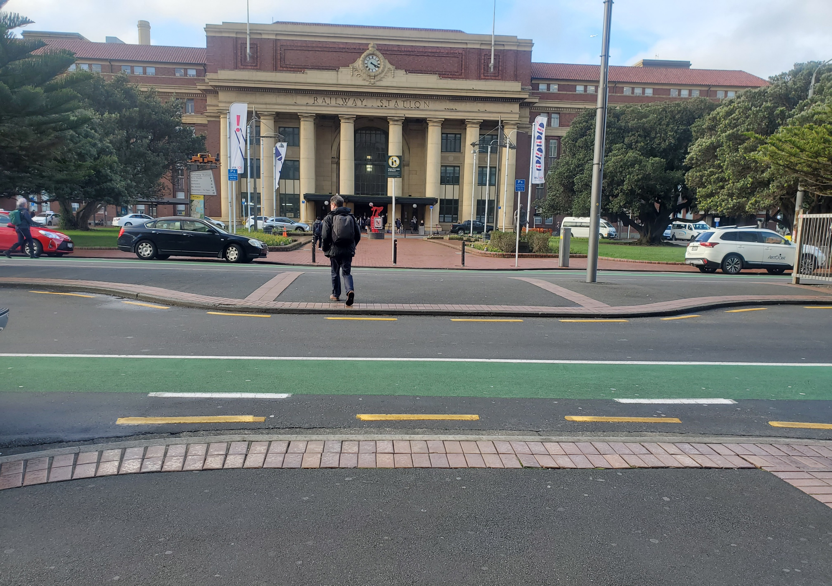


Bunny Street
Developed design stage
Safe system audit

Report prepared for
Wellington City Council
September 2025

This document has been prepared for the benefit of Client. No liability is accepted by ViaStrada Ltd, or any of its employees or sub-consultants with respect to its use by any other party.

Quality Assurance Statement
ViaStrada Ltd  Level 1,  284 Kilmore Street  Christchurch 8140  New Zealand  www.viastrada.nz | Project manager: | Glen Koorey, BE, ME(Civil), BSc, PhD  Director – Principal Transportation Engineer & Transportation Planner  027 739 6905  glen@viastrada.nz  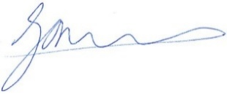
 | Prepared by: | Megan Gregory, BE, MET, CPEng  Principal Transportation Engineer  027 907 3431  megan@viastrada.nz  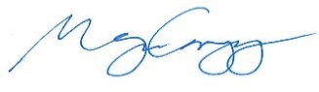
 | Reviewed by: | Glen Koorey
Project number:  Project name: | 1135-14  Cross City Bike Connections - Bunny Street
Document version |  |  | Date
Final report |  |  | 4/02/2026
First issue (for designer responses) |  |  | 5/09/2025
Disclaimer
The findings and recommendations in this report are based on the site visit undertaken by the safe system audit team (SSAT), an examination of available relevant plans, the specified road and environs, and the SSAT’s professional knowledge and experience. However, it must be recognised that no audit can guarantee the elimination of all possible safety concerns as all traffic environments consist of a multitude of elements that are never completely within the control of engineering design.
Safety audits, by nature, focus on aspects relating to transport safety and therefore do not constitute a complete review of design or assessment of standards with respect to engineering or planning documents. Similarly, the safety audit focuses on the plans provided and the relevant design stage.
This audit applies to the stated project. Whilst some issues covered are general and might be applicable to other locations, the SSAT does not take any responsibility for transferral of concepts to other projects or locations.
While every effort has been made to ensure the accuracy of the report, it is made available on the basis that anyone relying on it does so at their own risk without any liability to the safety audit team or their organisations.

Table of Contents
1. Introduction 1
1.1 Brief and project description 1
1.2 The safe system audit team 1
1.3 Meetings and site visits 1
1.4 Project information provided 1
1.5 Existing conditions 2
1.6 Crash history 2
1.7 Design vehicles 2
1.8 Items not covered 2
2. Safe system audit procedure 3
2.1 Project team response process 3
3. Identification of safety concerns 4
3.1 Bunny Street / Featherston Street / Thorndon Quay intersection 4
3.1.1 Potential for cyclists to enter intersection at the wrong time - Serious 5
3.1.2 Unintuitive positioning of primary cycle signals on Bunny Street cycleway approach - Significant 6
3.1.3 Unintuitive positioning of far-side cycle signals - Significant 12
3.1.4 Ambiguity of Bunny Street cycleway bend approach right-turn arrow marking - Significant 15
3.1.5 Disruptions to provision for cycleway bend from Bunny Street (movement C4) - Minor 17
3.1.6 Missing phase for cycleway bend from Thorndon Quay (movement C2) - Comment 18
3.1.7 Plans missing signal group numbers for Bunny Street cycleway primary cycle signals - Comment 19
3.1.8 Uncertainty regarding turning vehicle tracking conflicts between Thorndon Quay and Bunny Street - Comment 20
3.2 Bunny Street midblock 22
3.2.1 Appropriateness of raised platform - Comment 22
3.2.2 Pedestrian-cycle conflict at Bunny Street midblock pedestrian crossing - Minor 23
3.2.3 Westbound on-road cyclist access to cycleway - Significant 24
3.2.4 Tight turn into general traffic left turn / through approach lane on Bunny Street east approach - Minor 26
3.2.5 Lack of physical separation on cycleway approaching pedestrian crossing - Minor 28
3.2.6 Unintended turning into taxi loop exit - Moderate 29
3.2.7 Speed calming device on wrong side of cycleway at taxi loop exit - Significant 30
3.3 Bunny Street / Waterloo Quay / Lady Elizabeth Lane intersection 32
3.3.1 Likely reduced capacity of Lady Elizabeth Lane approach - Comment 32
3.3.2 Protection for pedestrians crossing Bunny Street - Significant 33
3.3.3 Potential for pedestrians and cyclists to confuse crossings on Lady Elizabeth side - Minor 35
4. Audit statement 37

List of Appendices
Appendix A Identification of safety concerns 39
A.1.1 Crash probability 39
A.1.2 Crash severity 39
A.1.3 Crash risk rating 40
A.1.4 Recommendations 41

Introduction

Brief and project description
ViaStrada (the safety auditors) have been commissioned by the Client to undertake a developed design stage safe system audit of Bunny Street (between and including its intersections with Featherston Street / Thorndon Quay and Waterloo Quay / Lady Elizabeth Lane) that complies with the NZ Transport Agency Waka Kotahi (NZTA) Safe System audit guidelines (2022).
Figure 1-1 shows the project location, in central Wellington:
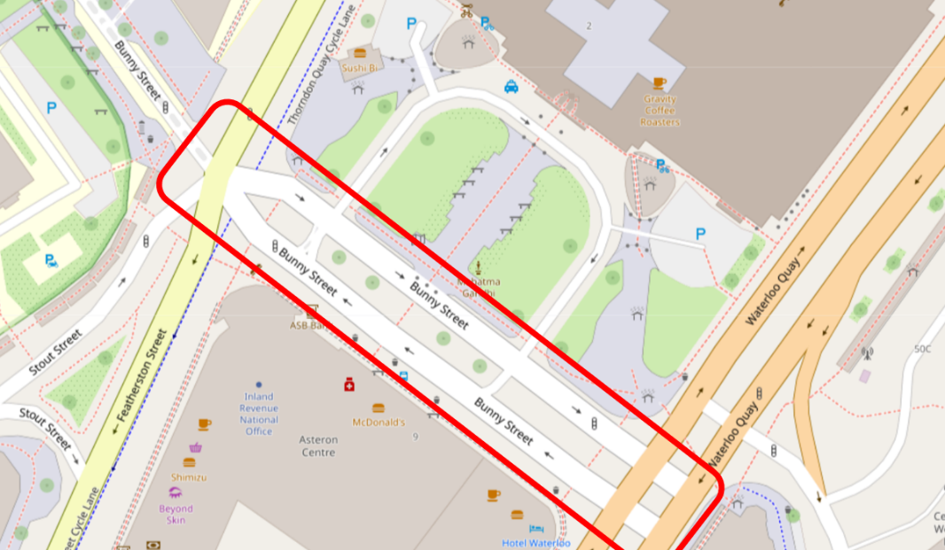
Figure 1-1: Extent of audit
The infrastructure assessed in this audit includes: signalised intersections, on-road cycling provisions, separated cycleway, pedestrian provisions, raised platforms, medians, and painted markings.
To date, a concept stage safe system audit has been undertaken for the Waterfront corridor, which includes the Bunny Street section and extends further south (ViaStrada, 19 August 2025).
This safe system audit includes an identification of safety concerns (described in Appendix A and detailed in section 3). An assessment of Safe System alignment has not been commissioned as part of this work, and it is assumed the relevant aspects have already been covered by WCC’s internal processes.

The safe system audit team
The safe system audit was carried out by the Safe System Audit Team (SSAT) consisting of:
- Glen Koorey, the safety audit team leader of ViaStrada Ltd
- Megan Gregory, a safety audit team member of ViaStrada Ltd
- Axel Downard-Wilke, a safety audit team member of ViaStrada Ltd
- Warren Lloyd, a safety audit team member of ViaStrada Ltd

Meetings and site visits
The daytime site visit (for the whole Waterfront Corridor including the Bunny Street section) was undertaken on 25 July 2025.
SSAT members were provided the Bunny Street Developed Design plans on 22 August 2025. On 28 August, SSAT members met with WCC team members via video call, to have a briefing and discuss the SSAT’s initial observations.

Project information provided
The SSAT has received the following plans and information on the roads and traffic within the audit area:
Table 1-1: documents received.
Document | Date | Description
5-C4731.00(1)_BUNNY ST DEVELOPED DESIGN_C000-C203.pdf | 22/08/2025 | Developed Design plans (layout plus signals) for Bunny Street, between Featherston Street and Waterloo Quay intersections inclusive.

Existing conditions
Table 1-2: Existing road conditions (source: MegaMaps or otherwise specified)
Transport Information | Bunny St
Road function (ONF) | Urban connector
Posted Speed (km/h) | 30
Mean operating speed (km/h) | 19
Land use (CSS - Commercial strip shopping) | CSS and urban residential
Traffic volume band (vpd) from WCC count dashboard | <1,000 to <12,000
Est. AADT (MobileRoad) | 8,430 westbound / 3,000 eastbound
Infrastructure risk score | Low medium to medium high

Crash history
The previous ViaStrada report, Cross City Bike Connections Concept Design SSA (ViaStrada, August 2025) details the crash history for two corridors: Waterfront and Featherston/Victoria. In this, the Bunny Street / Waterloo Quay intersection was identified as a major cluster, having experienced 16 non-injury and 2 minor injury crashes in the 5-year analysis period, with one of the injuries involving a vulnerable road user. Please refer to the previous report for more detail.

Design vehicles
At this stage, vehicle tracking been undertaken by the designers, and is not specifically considered by the SSAT.

Items not covered
This developed design stage safe system audit does not cover the aspects of:
- Vehicle tracking
- Street lighting
- Connections to other projects at route extents

Safe system audit procedure
The primary objective of a Safe System audit is to deliver a project that achieves an outcome consistent with the Safe System approach, that is, minimisation of death and serious injury. This audit follows the NZ Transport Agency Waka Kotahi (NZTA) Safe System Audit Guidelines (2022) with respect to the identification of safety concerns (see Appendix A).

Project team response process
In accordance with the procedures set down in the NZ Transport Agency Waka Kotahi (NZTA) Safe System Audit Guidelines (2022) the audit report will be submitted to the client who, will instruct the wider project team to respond.
No changes, however small they may appear, may be made to any of our writings in the main audit section of our report without our express review and consent.
The safety issues raised in this audit will require responses from the designer and the project safety engineer. Finally, the client decision and action taken against the safety issues will also be recorded.
We do not consent to any changes to be made to the main audit section of our report.
Project team members are to be identified by the client (Table 2-1).
Table 2-1: project team members
Role | Name | Organisation
Designer response | Sam Thornton | WSP
Safety engineer
Client decision
Action taken by

Identification of safety concerns

Bunny Street / Featherston Street / Thorndon Quay intersection
The following figures will be referred in several issues regarding the Bunny / Featherston / Thorndon intersection. The terminology used to describe the various separated cycleway and on-road cycle lane locations / directions is presented in Figure 3-1, and the intersection signal phasing diagram is presented in Figure 3-2.
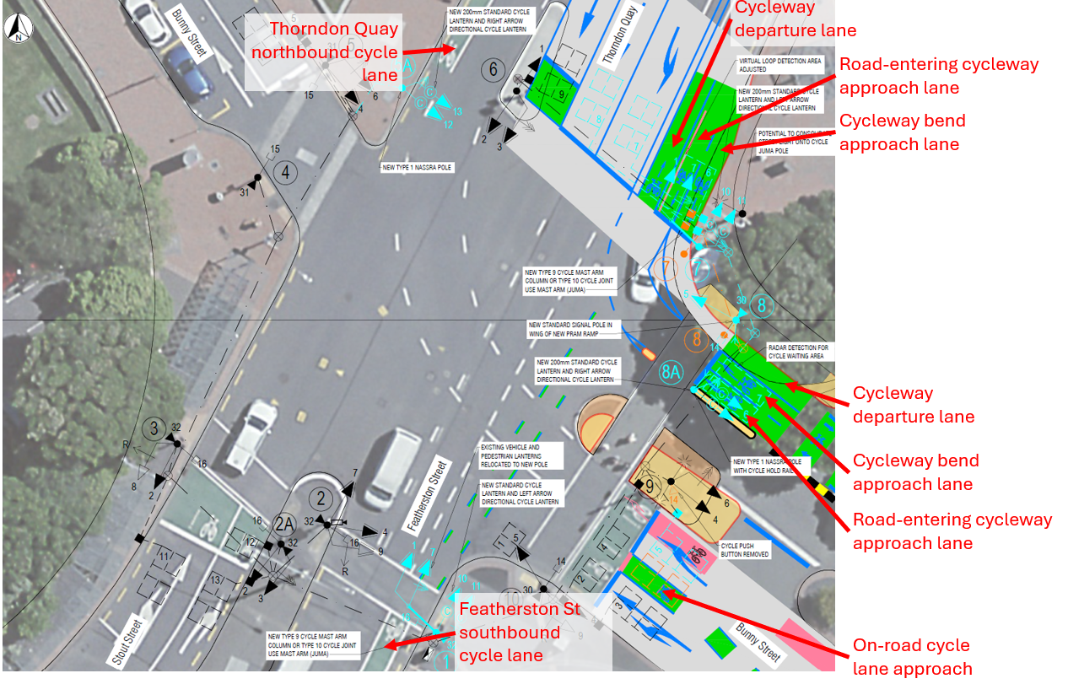
Figure 3-1: Bunny / Featherston / Thorndon approach and departure lane terminology for cycleways / cycle lanes
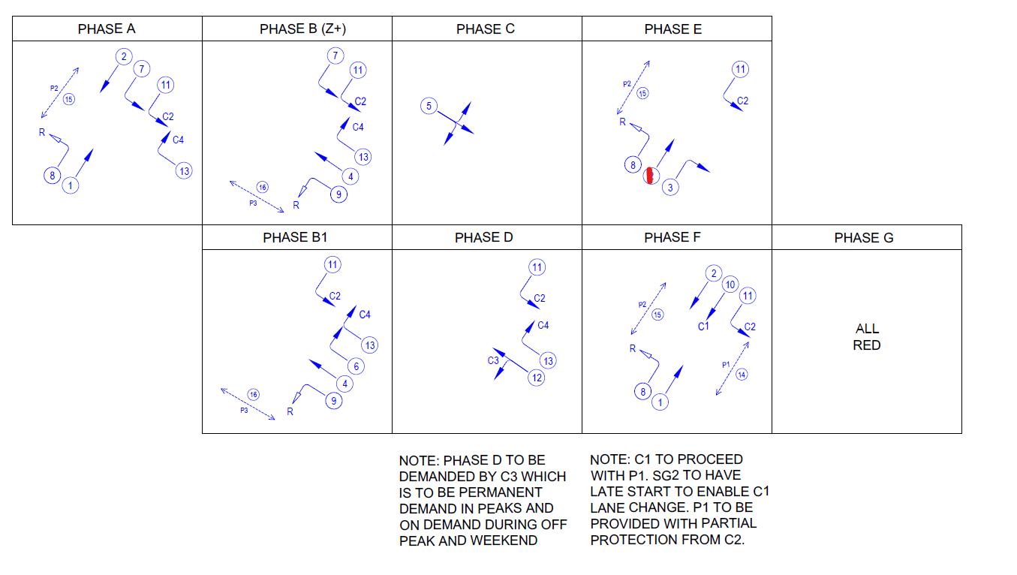
Figure 3-2: Bunny / Featherston / Thorndon signal phasing (note SG 1 label corrected in phase E)

Potential for cyclists to enter intersection at the wrong time - Serious
The safety issue is that cyclists coming from the cycleway or the on-road cycle lane on Bunny St or the advanced stop box on Thorndon Quay might think they can go when the cycleway bend movements (SG 11 for the Thorndon cycleway approach / SG 13 for the Bunny cycleway approach) run but the signals for road-entering cyclists (SG 10 / SG 12) are red (see Figure 3-2).  The crash type expected is motor vehicle vs cyclist.  There are a number of compounding factors that could contribute to cause this outcome; these are listed below, with some being discussed in individual sections:  - Unintuitive positioning of primary cycle signals on the Bunny Street cycleway approach (issue 3.1.2)  - Unintuitive positioning of far-side cycle signals (issue 3.1.3)  - Ambiguity of Bunny Street cycleway bend approach right-turn arrow marking (issue 3.1.4)  - General lack of familiarity with directional cycle signals / multiple cycle signal columns for a signal approach.  - People react to change – even if they understand the difference between the two cycle signals, road-entering cyclists may make a false start when they see SG 10 / SG 13 go green. |  | Probability of crash occurring |  | Likely
 |  | Expected crash severity |  | Serious injury
 |  | Primary treatment recommendations:
 |  |  | See the individual recommendations in issues 3.1.2, 3.1.3 and 3.1.4.
 |  | Supporting treatment recommendations:
 |  |  | See the individual recommendations in issues 3.1.2, 3.1.3 and 3.1.4.
 |  |  | Education / promotion to inform cycleway and road users about the increasing complexities of cycleway layouts and cycle signal operations.
The first three issues have been assessed separately; while each could result in a serious injury to a cyclist, they are individually considered unlikely to occur. However, when considered together, with the compounding effects of multiple ambiguities, it is likely that a crash due to a cyclist entering the intersection in the wrong phase will occur.
Note: the SSAT had considered an alternative layout concept involving an off-road path further away from the roadway, to avoid the need for directional cycle signals, reducing the confusion in this case. However, WCC staff have advised that this would not work, given the peak volumes of pedestrians and cyclists at the site, and the resulting likely conflicts between cyclists and pedestrians at the transition points and along the off-road path. The SSAT agrees with these concerns.
Responses:
Designer | Concerns noted, responses to individual issues below. Agree with education / promotion activities.
Safety Engineer | Agree with Designer response and also for the Project Manager and Traffic Signal Assets Team to check on-site prior to turning on the cycle displays. Project Manager and Traffic Signal Team will conduct a monthly review for the first 3 months on the intersection operations and address all identified safety risks.
Client | Agree.
Action | Add to monitoring plan

Unintuitive positioning of primary cycle signals on Bunny Street cycleway approach - Significant
The safety issue is that cyclists entering the road from the Bunny Street cycleway approach might think the signals for the cycleway bend (SG 13 – see Figure 3-2) in the primary position (i.e. at the limit line) apply to them, and proceed during the wrong phase.  The crash type expected is cyclist vs motor vehicle – depending on the phasing, the latter could be travelling at speeds likely to cause serious injury to a cyclist.  The risk factors include:  - Both columns of cycle signals (“standard” i.e. non-directional, and right turn) are located directly to the left of the cycleway approach lane for road-entering cyclists – meaning the signal column immediately adjacent to these cyclists is in fact the signal column for the cyclists continuing around the cycleway bend.  - Potential for primary cycle signals to be mounted at lower height, thus potentially visible to waiting cyclists.  - General lack of familiarity with directional cycle signals / multiple cycle signal columns for a signal approach.  - People react to change – even if they understand the difference between the two cycle signals, road-entering cyclists may make a false start when they see SG 13 go green.  - Compounding effects with other issues discussed in issues 3.1.3 and 3.1.4 |  | Probability of crash occurring | Unlikely
 |  | Expected crash severity | Serious injury
 |  | Primary treatment recommendations:
 |  |  | Separate the two cycle signal columns on the Bunny St cycleway approach, so that each clearly relates to a specific cycle lane – the best way to achieve this is likely to be a gantry over the cycleway.
 |  |  | Provide more logical positioning of the general traffic vs cycleway signals on the Thorndon Quay approach – locate the general traffic signals as close to the general traffic lanes as possible (i.e. allowing for clearances to heavy vehicles) and locate the cycle signals above their respective cycleway lanes.
 |  | Supporting treatment recommendations:
 |  |  | Signage to inform cyclists about the purpose of the two columns of cycle signals.
 |  |  | Education programmes to inform cyclists about directional cycle signals in general, plus the possibility of multiple cycle signal columns on a signal approach.
As directional cycle signals have not yet been incorporated into the TCD Rule, there is no official guidance regarding their placement and positioning. Draft guidance produced by SSAT members (who conducted the directional cycle signal trial research) includes the following:
Where directional cycle signals are used and there are multiple sets of cycle signals for different cycle movements from the same approach, it is also important to distinguish between these different sets of cycle signals. This can be achieved by:
- Marking separate approach lanes within the cycleway for each cycle movement.
- Physically separating the two (or more) sets of cycle signals (e.g. on different signal poles).
- Preferably, providing cycle signals over the middle of the lane they apply to
  - This could be achieved by installing a gantry or mast-arm
  - Where this is not possible, cycle signals should generally be to the left of the relevant cycleway approach lane.
The following photo illustrates a cycleway approach that satisfies the above principles, except for that of providing cycle signals over the middle of the lane (the next-best alternative of providing cycle signals to the left of the appropriate cycleway lane is satisfied).
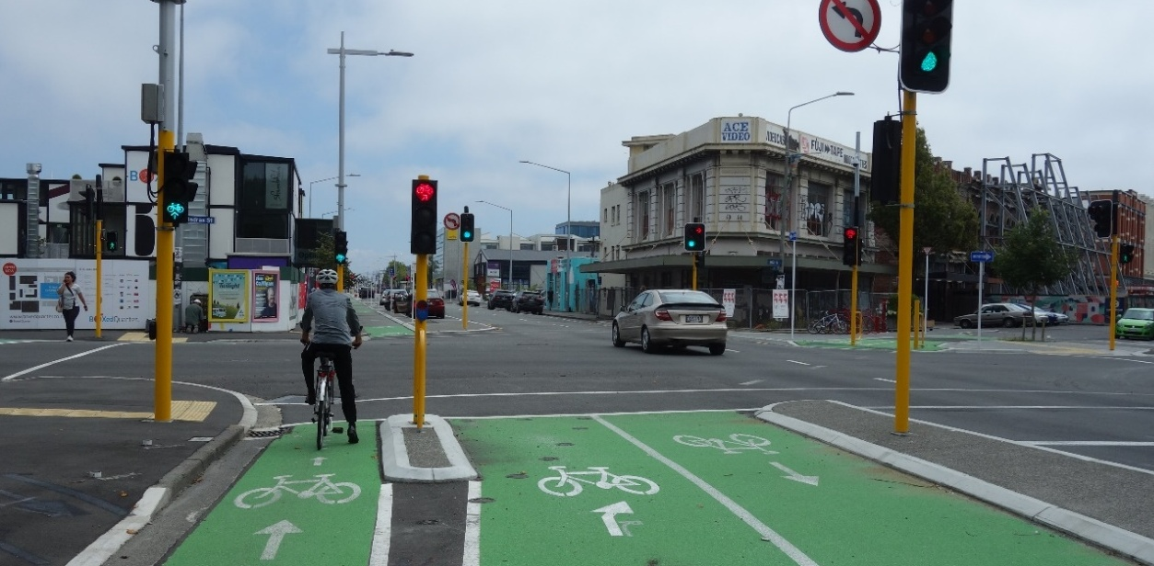
Figure 3-3: Good distinction between signals for separated cycleway vs roadway, and signals for different cycle directions (St Asaph Street at High Street / Madras Street, Christchurch)
This issue is more critical for the Bunny St cycleway approach. The design covers the first principle (separate approach lanes) but does not satisfy the other two principles. The SSAT acknowledges it would be tricky to achieve a splitter island between the two Bunny Street cycleway approach lanes on which to mount separate poles, but perhaps an overhead gantry for cycle signals could be achieved.
For the Thorndon Quay cycleway approach, the signals would be located next to the cycleway bend approach lane, and these cyclists would only face the risk of not proceeding when they are actually able to, which has no risk of conflict with motor traffic. Furthermore, while road-entering cyclists would have to look over the adjacent cycleway lane to see their signals, the closest column to them would be the column relating to their movement. However, it appears that the general traffic signals would be located on a mast-arm with two columns located in a central position above the cycleway approach lanes (Figure 3-4), which could cause extra confusion for cyclists and result in them progressing when there is a green for general traffic but not for a cycleway movement.
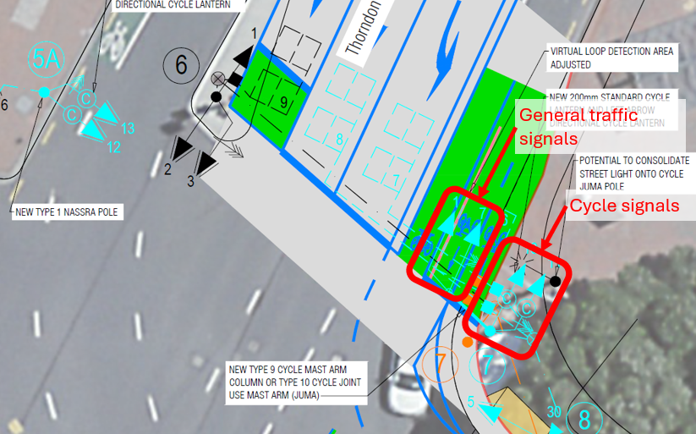
Figure 3-4: Thorndon Quay approach primary signals
Responses:
Designer | Concerns noted. Proposed design changes is to relocate the Thorndon Quay primary vehicle lanterns to an island between the traffic lane and cycleway. This would involve replacing a section of cycleway dividers with a 1.1m wide traffic island which provides sufficient clearance for a two column lantern. The cycleway would be narrowed to a 1.5m wide departure lane and two 1.25m wide approach lanes (no islands between cycleway lanes). A type 9 cycle mast arm column or type 10 cycle joint use mast arm would be located in the footpath (as previously proposed). A left turn cycle directional lantern would be mounted to the upright and a standard cycle lantern would be mounted on the outreach.  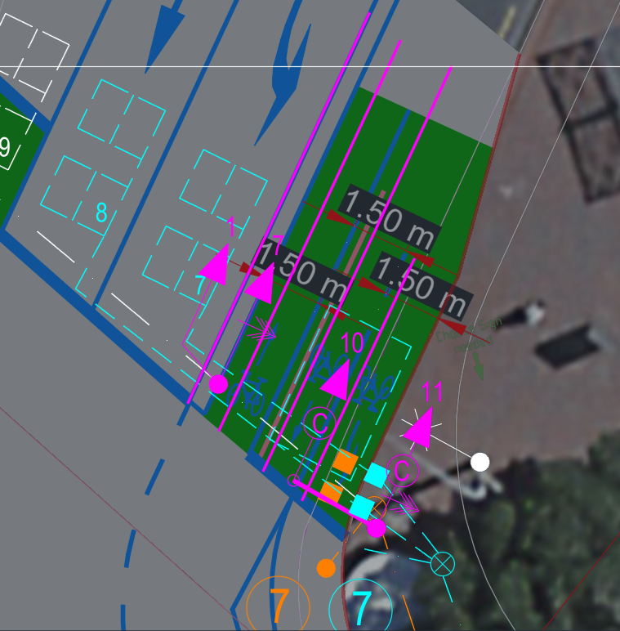  For the Bunny St approach the proposed design changes to use a type 9 cycle mast arm column with the standard cycle lantern mounted on the upright and the right turn lantern located on the outreach. This would place the right turn directional cycle lantern over the right turn cycle lane.  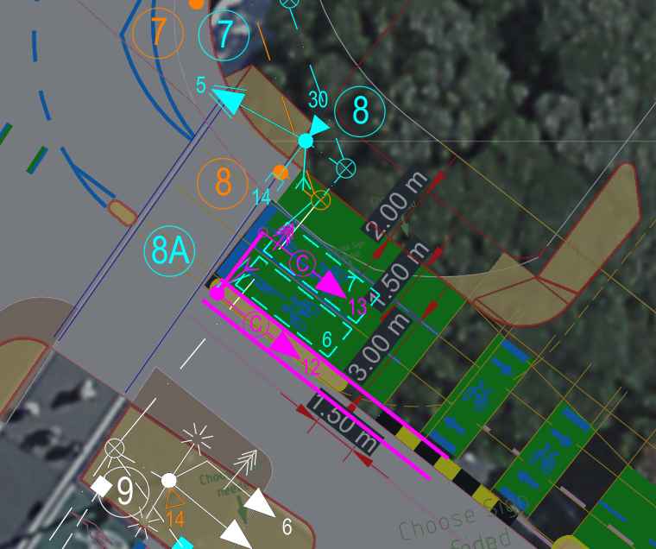
Safety Engineer | Agree to separate SG12 and SG13 lanterns and install a cycle outreach so that SG13 is over its lane. Install outreach for TQ cycleway as well. 5m mast arm outreach for TQ vehicles. Revised detailed design is to be provided to the Safety Engineer and Traffic Signals team to review and approve if the proposed changes are acceptable. The revised detailed design is to include the layout from kerb to kerb to understand the overall impact on this major transport corridor.
Client | Agree with responses and detail to be confirmed in the details design stage
Action | Confirm at detailed design review.

Unintuitive positioning of far-side cycle signals - Significant
The safety issue is that cyclists entering the road from the Bunny Street or Thorndon Quay cycleway approaches might think the signals for the cycleway bend (SG 10 / SG 13) in the far-side position (i.e. on the departure side of the intersection) apply to them, and proceed during the wrong phase.  The crash type expected is cyclist vs motor vehicle – depending on the phasing, the latter could be travelling at speeds likely to cause serious injury to a cyclist.  The risk factors include:  - Both columns of cycle signals (those for cyclists entering the road and progressing across the intersection, plus those for cyclists continuing around the cycleway bend) are located on the same pole on the departure side of the intersection, which means:  - cyclists continuing on the cycleway will probably not be looking in the direction of the far-side cycle signals, since they will be turning a short corner and not progressing across the intersection; and  - the far-side signals appear as if both columns are for cyclists entering the intersection; this is a particular concern for cyclists on the Bunny St on-road cycle lane or road-entering cycleway approaches who are planning on turning right onto the northbound on-road cycle lane on Thorndon Quay.  - General lack of familiarity with directional cycle signals / multiple cycle signal columns for a signal approach.  - People react to change – even if they understand the difference between the two cycle signals, road-entering cyclists may make a false start when they see SG 10 / SG 13 go green.  - Compounding effects with other issues discussed in issues 3.1.2 and 3.1.4. |  | Probability of crash occurring | Unlikely
 |  | Expected crash severity | Serious injury
 |  | Primary treatment recommendations:
 |  |  |  | Do not locate the far-side signals for the short-turn cycleway bend movements on the far-side of the intersection.
 |  |  |  | Consider whether they can be mounted on the departure side of the cycleway. This will be more feasible for the Thorndon – Bunny direction, as a signal pole could be located on the kerb. For the Bunny – Thorndon direction, consider whether an additional signal pole could be accommodated in the separator between the cycleway and the left-turn general traffic lane.
 |  | Supporting treatment recommendations:
 |  |  |  | Signage to inform cyclists about the purpose of the two columns of cycle signals.
 |  |  |  | Education programmes to inform cyclists about directional cycle signals in general, plus the possibility of multiple cycle signal columns on a signal approach.
As directional cycle signals have not yet been incorporated into the TCD Rule, there is no official guidance regarding their placement and positioning. The draft guidance referred to in issue 3.1.2 does not yet cover far-side cycle signal placement.
Responses:
Designer | Concerns noted, proposed design changes are:  - Mount far side SG11 lantern on new pole 8A in the island between traffic lane and cycleway which is visible to cyclists turning left. This leaves the SG10 cycle lantern on pole 1 for cyclists travelling to Featherston St  - Mount far side SG 13 lantern on a new standard pole between the traffic lane and cycleway which is immediately behind the departure side cycle lane for cyclists turning right into Thorndon Quay. This leaves the SG12 cycle lantern on pole 5A for cyclists going to Bunny St west  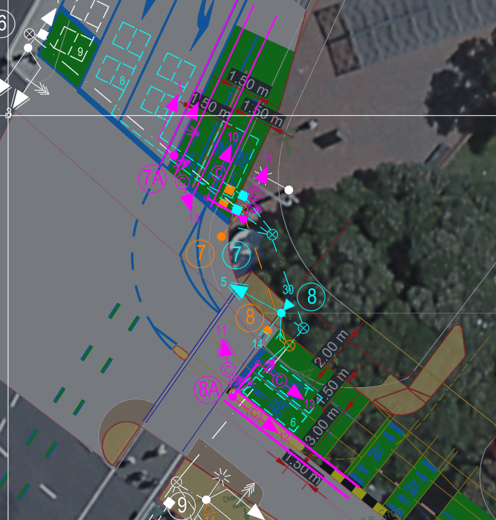
Safety Engineer | Agree with designer response. Same requirements on the review of detailed design as in 3.1.1 and 3.1.2 Safety Engineer comments.
Client | Agree with above responses
Action | To be updated in detailed design

Ambiguity of Bunny Street cycleway bend approach right-turn arrow marking - Significant
The safety issue is that cyclists approaching the intersection on the Bunny Street cycleway may mistake the right-turn arrow in the cycleway bend approach lane as being for turning right into the Thorndon Quay far-side northbound departure cycle lane, and undertake this manoeuvre when SG 13 is green but SG 12 is red.  The crash type expected is cyclist vs motor vehicle – depending on the phasing, the latter could be travelling at speeds likely to cause serious injury to a cyclist.  The risk factors include:  - Ambiguity between the two very different right turn destinations for cyclists coming from the Bunny St cycleway – both which could be denoted with a right-turn arrow (see Figure 3-5).  - Misleading continuity lines; the continuity line for drivers turning left from Thorndon Quay to Bunny Street, when viewed by cyclists coming from the Bunny Street cycleway, suggest the cycleway bend movement originates from the road-entering approach cycle lane (see Figure 3-5).  - General lack of familiarity with multiple cycle approach lanes / directions through intersection.  - Compounding effects with other issues discussed in issues 3.1.2 and 3.1.3  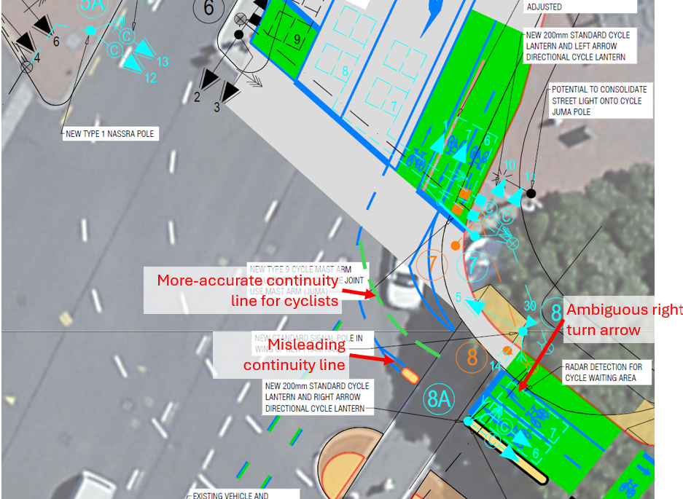  Figure 3-5: Ambiguous markings for right turn from Bunny Street cycleway |  | Probability of crash occurring |  | Unlikely
 |  | Expected crash severity |  | Serious injury
 |  | Primary treatment recommendations:
 |  |  | N/A
 |  | Supporting treatment recommendations:
 |  |  | Add a green continuity marking or lane line that better aligns with the cycleway bend approach lane (see Figure 3-5).
 |  |  | Consider whether the arrows in the Bunny St cycleway approach lanes could be replaced with text – e.g. “ROAD” and “CYCLE-WAY” (the latter being broken over two lines, so it fits within the lane, at a reasonable size).
Responses:
Designer | Concern noted, departure (on-road) cycle lane doesn’t exist (aerial used for drawing is out of date). Agree to add continuity line as per Fig 3-5.
Safety Engineer | Agree with Designer response. Same requirements on the review of detailed design as in 3.1.1 and 3.1.2 Safety Engineer comments.
Client | Agree with above responses
Action | Address in detailed design

Disruptions to provision for cycleway bend from Bunny Street (movement C4) - Minor
The safety issue is that cyclists travelling around the cycleway bend originating from Bunny Street (movement C4 / signal group 13) may get fed up with the stop-start nature of this movement, and progress in a phase when they have a red light.  Under the proposed phasing (Figure 3-2):  - Phase A – C4 can go  - Phase B – C4 can go  - Phase C – C4 red light (presumably to avoid conflict with cyclists coming from Bunny St west approach and entering the cycleway)  - Phase D – C4 can go  - Phase E – C4 red light (to avoid conflict with cyclists coming from the Thorndon Quay cycleway approach and progressing through the intersection)  - Phase F – C4 red light (to avoid conflict with crossing pedestrians)  I.e. there are three times in a cycle where C4 cyclists are expected to stop, of which only one (Phase F) is probably warranted. |  | Probability of crash occurring | Unlikely
 |  | Expected crash severity | Minor injury
 |  | Primary treatment recommendations:
 |  |  |  | N/A
 |  | Supporting treatment recommendations:
 |  |  |  | Swap the phasing order to A-B-D-C-E-F. That way, there would only be one period when the C4 movement has to stop.
The crash types expected is cyclist vs cyclist.
The risk factors include:
- Expected low volumes of cyclist coming from Bunny St west in Phase C – therefore conflict of risk is rare and frequent cycleway users may get used to continuing during this phase, putting them at risk when cyclists do come from Bunny St west. (This could also be a risk for the C2 movement).
The corresponding cycleway bend movement coming from Thorndon Quay (C2) operates in Phase E; C4 cyclists seeing this may assume they can also go.
Responses:
Designer | For phase C SG13 was not included because it conflicts with cyclists going Bunny St west to Bunny St east. It is acknowledged that this movement is low volume and is good sightlines. However adding SG13 would mean that cyclists would receive a green right turn arrow (positive confirmation of priority) but would need to giveway to cyclists going straight. This phasing is not TCD compliant but there is a low safety risk.  For phase E SG13 was excluded because of the cycle movement from Stout St to Thorndon Quay which is high volume in the afternoon peak, is high speed due to 34m clearance distance and cyclists would not be expecting to check to their left when turning right. Would not want to run SG13 in phase E for these reasons.  Agree with reordering phases to align SG 13 movements.  SG13 would receive approx. 85 sec green time out of 120 sec in morning peak under typical phase lengths of A, B and D (phase C runs infrequently) this is 70% green time which is excellent LOS.
Safety Engineer | Agree with Designer’s response. Max CL for the intersection would be 110s instead of 120s. Same requirements for detailed design as in 4.1.1 and 4.1.2 Safety Engineer comments.
Client | Agree with responses above
Action | Address in detailed design

Missing phase for cycleway bend from Thorndon Quay (movement C2) - Comment
The SSAT note that cyclists travelling around the cycleway bend originating from Thorndon Quay (movement C2 / signal group 11) are not given a movement during Phase C.  Other than presumably to avoid conflict with any cyclists coming from the Bunny St west approach and entering the cycleway during this phase, there is no obvious reason why they can’t continue going. |  | Probability of crash occurring |  | N/A
 |  | Expected crash severity |  | N/A
 |  | Primary treatment recommendations:
 |  |  | N/A
 |  | Supporting treatment recommendations:
 |  |  | Provide additional C2 movement in Phase C
Responses:
Designer | Same response as 3.1.5, cycle volumes out of Bunny St west are low but left turning cyclists from Thorndon Quay would receive a green cycle left turn arrow so the proposed phasing would not be TCD compliant. Phase C runs in frequently (4 out of 36 phases in morning peak on 1 Aug 2025) so impact of not running SG11 is small. Most of the time SG11 would only be stopped for P1 so would have excellent LOS 135 sec out of 140 sec
Safety Engineer | Agree with the Designer. Max CL is 110s instead of 140s.
Client | Agree with above responses
Action | Address in detailed design

Plans missing signal group numbers for Bunny Street cycleway primary cycle signals - Comment
As shown in Figure 3-6, the signal group numbers (12 and 13) have been omitted from the primary cycle signals on the Bunny Street cycleway approach.  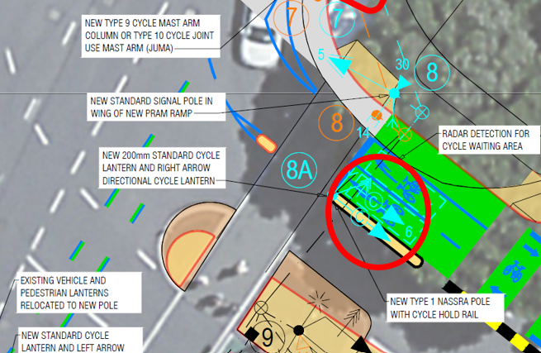  Figure 3-6: Signal group numbers for Bunny Street primary cycle signals missing |  | Probability of crash occurring |  | N/A
 |  | Expected crash severity |  | N/A
 |  | Recommendations:
 |  |  | Add signal group numbers
Responses:
Designer | Agree with recommendation.
Safety Engineer | Agree with the Designer’s response.
Client | Agree with above responses
Action | Address in detailed design

Uncertainty regarding turning vehicle tracking conflicts between Thorndon Quay and Bunny Street - Comment
The SSAT’s understanding is that a Z+ flag is used to repeat a phase at an intersection, however, while the B phase (Z+) and B1 phases include almost all the same movements, B1 includes the left turn from Thorndon Quay to Bunny Street, whereas B includes the right turn from Bunny Street to Thorndon Quay.  It is assumed that this is because there could be a conflict if heavy vehicles are undertaking these movements simultaneously, specifically that the left-turn movement may have to swing out over the path of the right turner. However, if this is the case (and without having seen the design vehicle tracking) the SSAT wonders whether the left turner would also track over the splitter island nose.  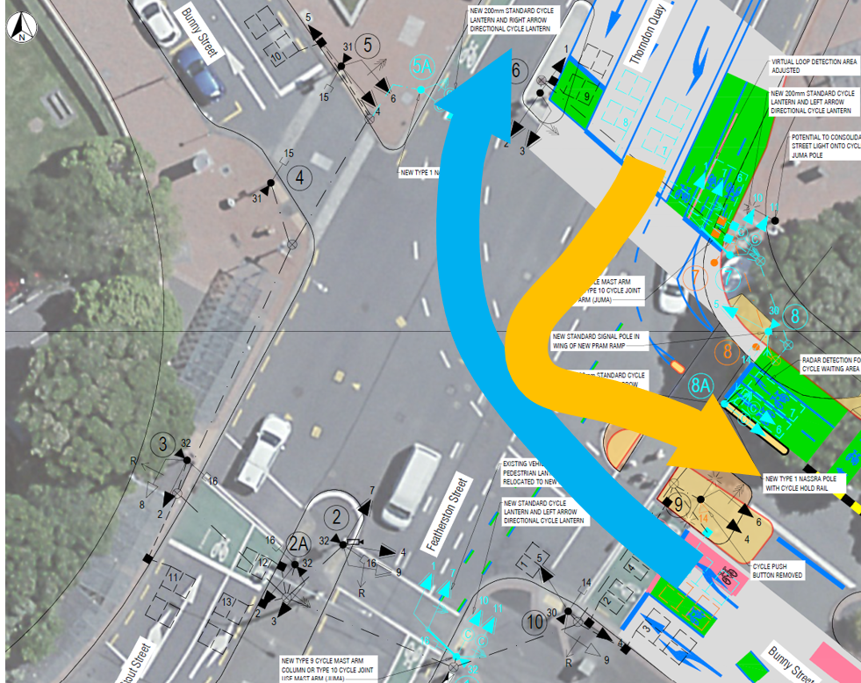  Figure 3-7: Crude attempt at trying to understand why these turns can’t run in the same phase |  | Probability of crash occurring |  | N/A
 |  | Expected crash severity |  | N/A
 |  | Recommendations:
 |  |  | Confirm via vehicle tracking whether the movements in Figure 3-7 can run in the same phase, and whether the island nose will get run over.
Responses:
Designer | Tracking confirms that right turn and left turn can run together so SG6 to be included in both B and B1 phases.
Safety Engineer | Remove B1 phase and add SG6 to B phase
Client | Agree with safety engineer
Action | Advise designer and address in detailed design

Bunny Street midblock

Appropriateness of raised platform - Comment
The SSAT has considered the appropriateness of the raised platform to aid pedestrians crossing Bunny Street at the midblock.  The Pedestrian Network Guidance (PNG section 3.4) distinguishes between two similar types of non-priority crossing: courtesy crossing and pedestrian platform. Both involve a raised platform, but courtesy crossings are designed to have higher ambiguity regarding who has priority and thus tend to have colours / surfaces that contrast the road and are used in lower speed environments (ideally 20 km/h or less). Pedestrian platforms have a similar look to the road and can be used in environments with vehicle operating speeds of up to 50 km/h; they are designed to reduce vehicle speeds whilst having a stronger emphasis that pedestrians must give way to vehicles. |  | Probability of crash occurring |  | N/A
 |  | Expected crash severity |  | N/A
 |  | Recommendations:
 |  |  | Retain the proposed pedestrian platform across the Bunny St midblock.
 |  |  | Monitor future road user behaviour once installed, to consider zebra provision later.
Both crossing types are recommended as “ideally suitable for low vehicle volume roads (up to 7,500 vpd depending on the road corridor)” – Bunny Street, which carries approximately 11,400 vpd, is well-above this threshold. Furthermore, it is classified in the ONF as an Urban Connector, whereas courtesy crossings are recommended for Activity Streets and Main Streets and pedestrian platforms are recommended for Local Streets and Activity Streets.
Despite Bunny Street having higher vehicle volumes and a different classification to the PNG’s recommendations, the SSAT agree that a pedestrian platform is the most appropriate provision in this location. This is due to the railway station resulting in extremely high pedestrian volumes crossing the Bunny Street midblock (note the PNG criteria do not consider pedestrian volumes).
At present, pedestrians tend to cross anywhere along the midblock; the platform will channel more pedestrians to use the same crossing point, making their crossing more predictable.
The SSAT considers a pedestrian platform will strike a better balance between pedestrians giving way to motor vehicles and “forcing” their way across the road than a courtesy crossing. The previous design involved a zebra crossing, but there were concerns that this would result in vehicles queuing back through the adjacent intersections – a courtesy crossing would likely achieve the same result. It would be useful to monitor actual behaviour once the crossing is installed.
The platform will also improve accessibility for people with limited mobility or visual impairments. Currently, there are no kerb cutdowns and pedestrians have to step off and onto kerbs either side of the road and at the central median island.
Responses:
Designer | Concerns noted, agree to approach to monitor road user behaviour (no change to design proposed)  Also note latest traffic counts (2021) are 8,300-9,100 vehicles per day (see below). Vehicle capacity to be reduced through proposed changes (e.g. removal of second right turn lane into Waterloo Quay) which is expected to reduce demand further.  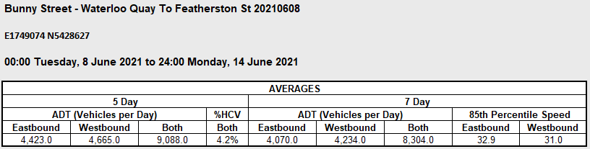
Safety Engineer | Agree with Designer response. Add to Monitoring Plan, checking for safe pedestrian crossing behaviour. If there is an issue, consider changing it to a priority crossing.
Client | Agree with responses.
Action | Add to Monitoring Plan.

Pedestrian-cycle conflict at Bunny Street midblock pedestrian crossing - Minor
The safety issue is that pedestrians crossing the two-way cycleway on Bunny Street may not expect cyclists to be coming from the contra-flow direction.  The crash type expected is pedestrian vs cyclist.  The risk factors include:  - In this location, pedestrians only have to think about one direction of general traffic at a time, and would likely expect cyclists to be coming from the same direction as the general traffic.  - Two-way on-road cycleways of this nature are reasonably rare in Wellington.  - High cycle and pedestrian volumes.  There is little guidance relating to providing for pedestrians crossing two-way cycleways; however, there is guidance regarding drawing motorists’ attention to looking both ways when crossing two-way cycleways at driveways or side streets – specifically the CNG technical note: High-use driveway treatment for cycle paths and shared paths. The proposed plans already cover one important element – contrasting colour, but would benefit from using directional arrows.  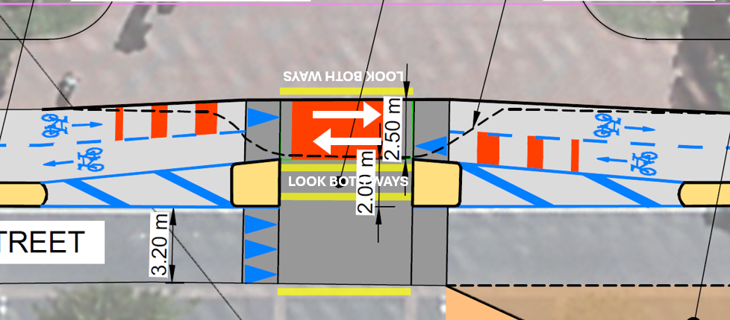  Figure 3-8: Proposed marking additions at pedestrian-cycle conflict point |  | Probability of crash occurring |  | Unlikely
 |  | Expected crash severity |  | Minor injury
 |  | Primary treatment recommendations:
 |  |  | N/A
 |  | Supporting treatment recommendations:
 |  |  | Add arrows showing cycleway directions across the pedestrian crossing (see Figure 3-8).
 |  |  | Add “look both ways” markings approaching the conflict point (see Figure 3-8).
Responses:
Designer | Agree with recommendations.
Safety Engineer | Agree with Designer response.
Client | Agree with responses.
Action | Addressed in final Developed Design.

Westbound on-road cyclist access to cycleway - Significant
The safety issue is that some cyclists travelling in the on-road westbound cycle lane on Bunny Street may want to transition to the separated cycleway but, depending on the location, this will result in conflict with other users.  The crash types expected are cyclist vs motor vehicle, pedestrian, or another cyclist.  Figure 3-9 shows the three main options for where this would occur.  - Option 1 (using raised mid-block crossing) would result in cyclists conflicting with pedestrians in this high-foot-traffic area, plus potential for conflict with eastbound cyclists when trying to make a tight turn on to the cycleway at its narrowest point.  - Option 2 (using taxi entrance gap) would risk conflict with motor vehicles heading west or east along Bunny Street, plus those turning into the Railway Station taxi loop.  - Option 3 (using signalised crosswalk) would risk conflict with pedestrians on the signalised crosswalk, or motor vehicles, depending on the signal phase, plus, cyclists may have to make an awkward manoeuvre to get behind the approach limit line on the cycleway, or risk conflict with through cycles coming from the Thorndon Quay cycleway approach. |  | Probability of crash occurring |  | Likely
 |  | Expected crash severity |  | Serious injury
 |  | Primary treatment recommendations:
 |  |  | N/A
 |  | Supporting treatment recommendations:
 |  |  | Undertake brief risk assessment of the most suitable alternate option for on-road cyclists heading for the separated cycleway.
 |  |  | Identify design measures to support the chosen option (e.g. green crossing markings for Option 1, a small cycle box in the taxi entrance median gap for Option 2).
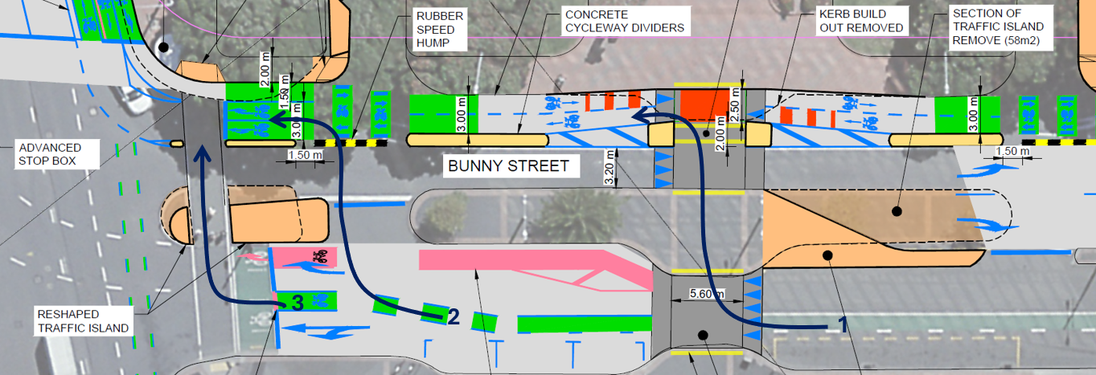
Figure 3-9: Three main options for cyclists transitioning from Bunny Street cycle lane to cycleway
The risk factors include:
- Multiple options for making this manoeuvre, but little guidance as to where it should occur
- Cyclists having to check behind them for approaching conflicting traffic.
- Uncommon cycleway layout.
Responses:
Designer | Concerns noted, option 2 is the intended use. Following discussions with Council, the intention is to remove the marked westbound cycle lane on Bunny Street west of the platform as shown indicatively below.  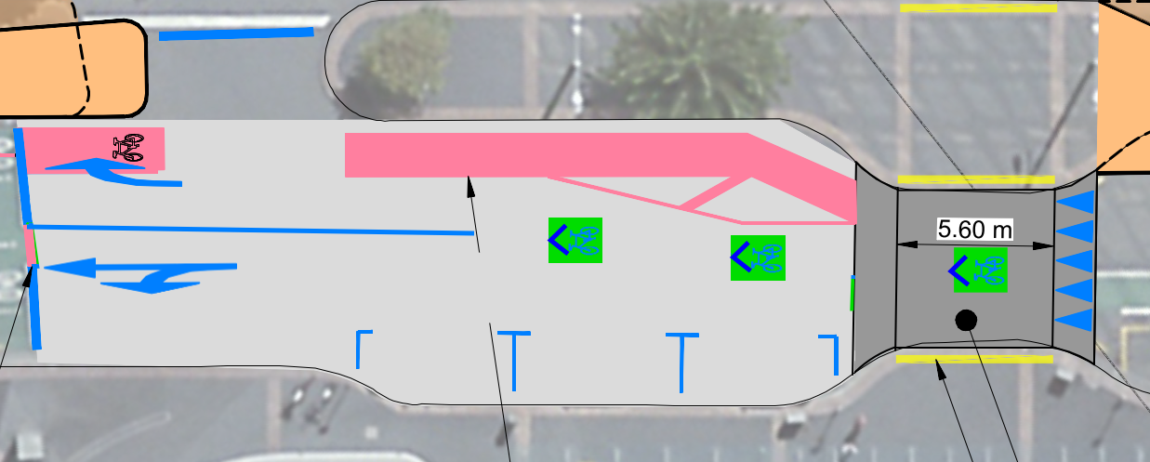
Safety Engineer | Agree with Designer response. Add issue to Monitoring plan, to confirm that Option 2 is prevalent.
Client | Agree with responses.
Action | Addressed in final Developed Design and to be included in Monitoring plan.

Tight turn into general traffic left turn / through approach lane on Bunny Street east approach - Minor
The safety issue is that vehicles in the shared left-turn / through lane on the Bunny Street east approach are likely to hang over the cycle lane, forcing cyclists into the general traffic lane (see Figure 3-10).  The crash type expected is motor vehicle vs cyclist.  The risk factors include:  - Traffic volumes for the left-turn and through movements (unknown to the SSAT)  - Likely presence of parked vehicles in the adjacent kerbside parking spaces  - Tight turning geometry for vehicles entering the left-turn / through lane  - Short storage space in the left-turn / through lane  - Potential for drivers to be rushing to catch a green light  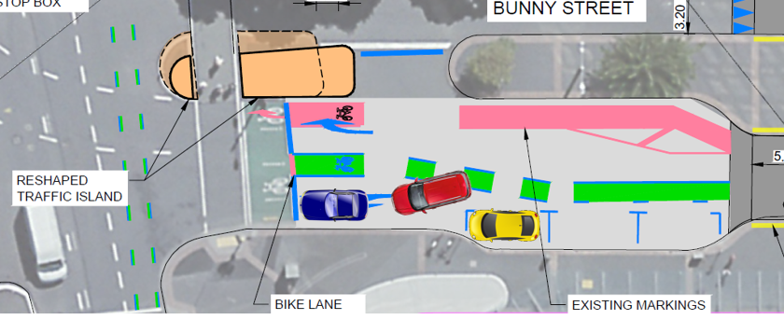  Figure 3-10: Vehicles anticipated to block cycleway approaching Featherston St |  | Probability of crash occurring |  | Unlikely
 |  | Expected crash severity |  | Minor injury
 |  | Primary treatment recommendations:
 |  |  | N/A
 |  | Supporting treatment recommendations:
 |  |  | Begin the cycle lane taper earlier (i.e. further east), corresponding with the widening of the traffic lanes, to achieve more clearance between the cycle lane and the left-turn / through lane.
Responses:
Designer | Concerns noted, as per above, the intention is to remove the marked westbound cycle lane on Bunny Street west of the platform as shown indicatively below.
Safety Engineer | Agree with Designer response.
Client | Agree with responses.
Action | Addressed in final Developed Design.

Lack of physical separation on cycleway approaching pedestrian crossing - Minor
The safety issue is that there are gaps in the physical separation on the Bunny Street cycleway, which could encourage motor vehicles to inadvertently enter the cycleway or attempt to park there (see Figure 3-11).  The crash type expected is motor vehicle vs cyclist.  The risk factors include:  - High volumes of taxi / uber drivers in the vicinity of the Railway Station  - Reduced taxi parking in the taxi loop  - Limited on-street parking availability  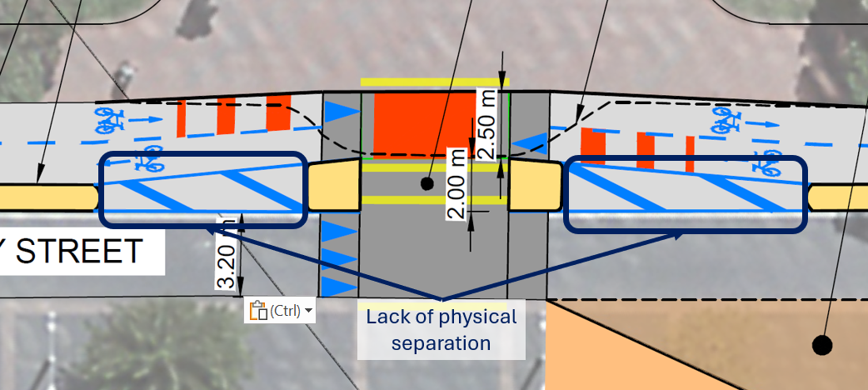  Figure 3-11: Missing physical separation in vicinity of pedestrian crossing |  | Probability of crash occurring |  | Unlikely
 |  | Expected crash severity |  | Minor injury
 |  | Primary treatment recommendations:
 |  |  | Add physical separation to the areas indicated in Figure 3-11.
 |  | Supporting treatment recommendations:
 |  |  | N/A
Responses:
Designer | Agree with parking concern, can add broken yellow lines to hatch area. Previous concern raised about pedestrians tripping on cycleway separator which is why a section of cycleway separator was removed from the design
Safety Engineer | Agree with Designer response.
Client | Agree with responses.
Action | Addressed in final Developed Design.

Unintended turning into taxi loop exit - Moderate
The safety issue is that drivers on Bunny Street might try to turn into the taxi loop exit, due to the positioning of the left-turn arrow marking (see Figure 3-12)  The crash type expected is head-on motor vehicle vs motor vehicle (if a driver turns in unaware that a taxi is exiting) or right-angle motor vehicle vs cyclist (if a driver realises their error but gets flustered and fails to check for cyclists).  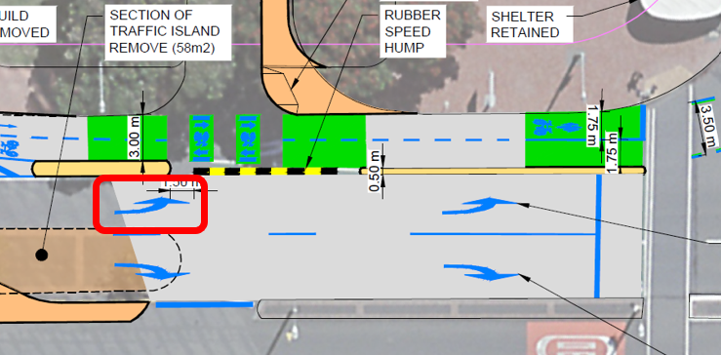  Figure 3-12: Confusing left-turn arrow approaching taxi loop exit  The risk factors include:  - Left-turn arrow located directly near the taxi loop exit, meaning it could be mistaken as denoting a turn into the exit.  - Lack of painted arrow or “NO ENTRY” text on the taxi loop exit  - “No-entry” signs on taxi loop exit obscured by large trees  - Two-way cycleway; drivers not expecting cyclists in the contra-flow direction, increased cognitive demands. |  | Probability of crash occurring |  | Likely
 |  | Expected crash severity |  | Minor injury
 |  | Primary treatment recommendations:
 |  |  | Relocate the two left-turn arrows further forward.
 |  | Supporting treatment recommendations:
 |  |  | Forgo the initial lane arrows – they are not needed for this short lane length, especially given the lower vehicle operating speeds.
 |  |  | Add painted arrow and “NO ENTRY” text on the taxi loop exit.
 |  |  | Bring the “NO ENTRY” signs forward of the trees and ensure they are sufficiently visible.
 |  |  | Despite the fact that the black and yellow speed hump should technically only be required on the taxi loop exit side (see issue 3.2.7) retain the one proposed on the Bunny Street side as well. The SSAT considers that removing the speed hump in this location would make the prohibited turn into the taxi exit look more “inviting” compared with installing it.
The relevant guidance is the TCD Manual Part 4, which states “Any intermediate sets of lane use arrows should be placed at about 80 m spacing, however distances may be varied to suit individual situations.” And: “Care should be taken when marking lane arrows to avoid confusion as to which side road it refers, especially when other side roads are closely spaced, or busy private access ways are present close to the intersection.”
Responses:
Designer | Agree with recommendations.
Safety Engineer | Agree with Designer response.
Client | Agree with responses.
Action | Addressed in final Developed Designs.

Speed calming device on wrong side of cycleway at taxi loop exit - Significant
The safety issue is that drivers exiting the taxi loop will not be forced to slow their speed prior to crossing the cycleway.  There is a speed calming device – the black and yellow speed hump circled in Figure 3-13 – however, this is on the departure side of the cycleway rather than the approach.  The crash type expected is motor vehicle vs cyclist.  The risk factors include:  - Prevalence of taxi drivers in this location  - Drivers potentially rushing to get a gap in traffic, or catch a green light at the nearby signalised intersection.  - Two-way cycleway; drivers not expecting cyclists in the contra-flow direction.  - Cycle volumes.  The relevant guidance is the CNG technical note: High-use driveway treatment for cycle paths and shared paths, which shows speed calming devices on the approach to cycleways.  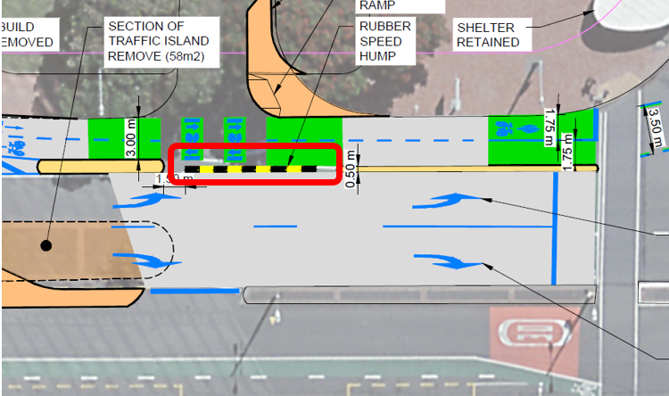  Figure 3-13: Proposed speed calming device will not slow vehicles exiting taxi loop prior to cycleway |  | Probability of crash occurring |  | Unlikely
 |  | Expected crash severity |  | Serious injury
 |  | Primary treatment recommendations:
 |  |  | Locate a speed hump on the taxi loop approach to the cycleway.
 |  | Supporting treatment recommendations:
 |  |  | In accordance with issue 3.2.6, retain the incorrectly positioned speed hump indicated in Figure 3-13, to help deter the wrong turn into the taxi exit.
Responses:
Designer | Agree with recommendations. Additional hump prior to pedestrian crossing point as indicated below.  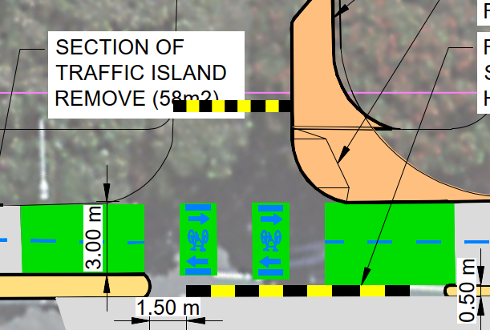
Safety Engineer | Agree with Designer response.
Client | Agree with responses.
Action | Addressed in final Developed Design by adding a raised platform at entrance and exit.

Bunny Street / Waterloo Quay / Lady Elizabeth Lane intersection
Figure 3-14 shows the proposed phasing diagram for the Bunny Street / Waterloo Quay / Lady Elizabeth Lane intersection; this will be referred to in the following issues.
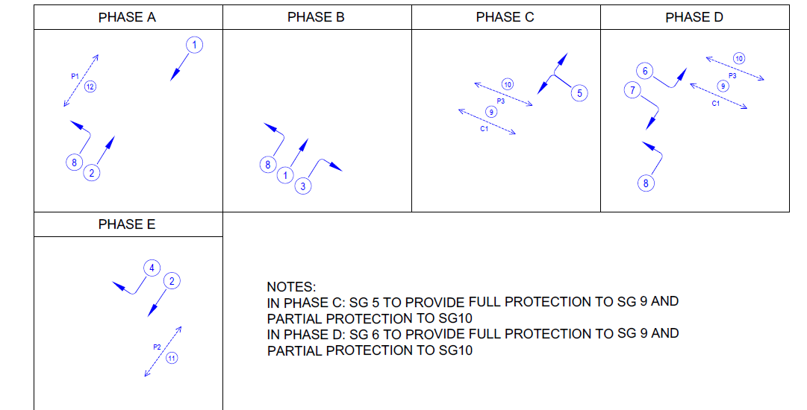
Figure 3-14: Bunny / Waterloo / Lady Elizabeth proposed phasing

Likely reduced capacity of Lady Elizabeth Lane approach - Comment
The Lady Elizabeth Lane approach to the Bunny / Waterloo intersection has been reduced from two lanes to one lane. Furthermore, the SSAT has been informed that the pedestrian crosswalk across Waterloo Quay does not currently run in this phase, but the proposal adds the pedestrian crosswalk (with partial protection) and the cycle crossing (with full protection) to the C phase (see Figure 3-14).  The SSAT understands that Lady Elizabeth Lane experiences brief but heavy traffic peaks when a ferry unloads vehicles. The reduction from two to one lane and introduction of pedestrian and cycle crossing movements in the C phase will exacerbate the situation. This will likely result in long queues and / or substantial extensions to the C phase (depending on how exactly the intersection phasing split is operated). The extent of this cannot be confirmed without intersection modelling. |  | Probability of crash occurring |  | N/A
 |  | Expected crash severity |  | N/A
 |  | Primary treatment recommendations:
 |  |  | N/A
 |  | Supporting treatment recommendations:
 |  |  | Undertake intersection modelling to determine the likely queue lengths and level of service to motor vehicles on Lady Elizabeth Lane, and confirm whether this aligns with WCC’s intended provision.
While a reduction in efficiency can lead to safety issues, the SSAT does not anticipate this at this location. There are several protective factors:
- Full protection provided to the cycle crossing
- Partial protection provided to the pedestrian crossing
- Full and partial protection will be provided to the whole approach i.e. to both left turners and right turners (while right turns don’t have any potential for conflict in C phase, if only a left-turn arrow were applied, they would likely get frustrated and try to bypass waiting left turners, or toot and encourage left turners to infringe the red light).
- A tight radius that will control the speed at which left turners can turn towards the crossing
- Drivers on the Lady Elizabeth Lane approach will have good visibility to any crossing users
- Splitter island channelling the approach and preventing drivers from encroaching onto the departure lane.
The SSAT supports the measures undertaken to gain more space on the corner for pedestrians and cyclists, given the numerous potential conflict points among the various different trajectories.
Responses:
Designer | Concerns noted. Pedestrian and cycle phase to be removed from phase C.
Safety Engineer | Recommend P3 stay on C phase. Most of the time the pedestrian walk runs in D phase which comes before C phase, then doesn't need to additionally run in C. Can leave C phase if the sequence remains the same and it is unlikely to cause an issue.
Client | Agree with responses.
Action | To be referred to designer and addressed in Detailed Design

Protection for pedestrians crossing Bunny Street - Significant
The safety issue is that the plans do not indicate that partial protection will be provided for the P1 movement, i.e. pedestrians crossing Bunny Street at the signalised intersection (SG 12).  The crash type expected is motor vehicle vs pedestrian.  The risk factors include:  - High pedestrian volumes  - Inconsistency with other crosswalks at this intersection and other intersections throughout the city, where pedestrian protection is the norm  - Intersection geometry allows for a reasonably fast left turn in this location  The relevant guidance is the Stops and Goes of Traffic Signals which states “Where the number of pedestrian/vehicle conflicts is high, pedestrian protection using red arrow control should be considered.”  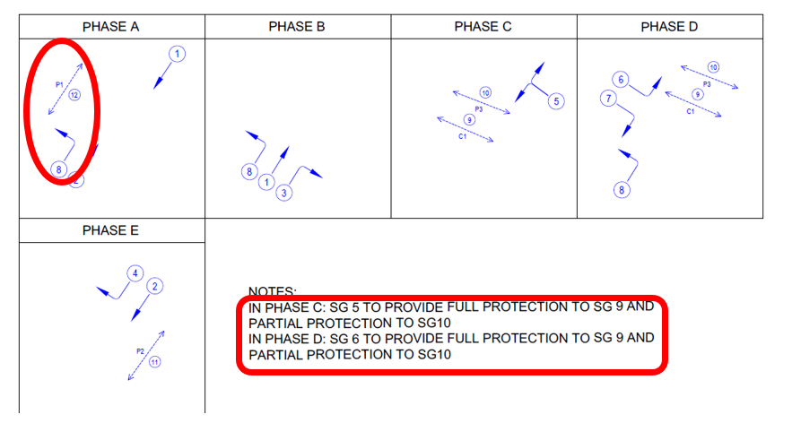  Figure 3-15: No protection to SG 12 |  | Probability of crash occurring |  | Unlikely
 |  | Expected crash severity |  | Serious injury
 |  | Primary treatment recommendations:
 |  |  | N/A
 |  | Supporting treatment recommendations:
 |  |  | Provide partial pedestrian protection for pedestrians crossing Bunny Street (SG 12 / P1) by applying a red left-turn arrow to SG 8.
Responses:
Designer | Agree with recommendations (as per existing operation).
Safety Engineer | Recommend partial ped protection for both SG9 and SG10. Don’t need full protection as left turners in D phase would get ~5 seconds of green time. Agree with partial ped protection for SG8 (as per existing operation).
Client | Agree with responses.
Action | Refer to designer and address in Detailed Designs.

Potential for pedestrians and cyclists to confuse crossings on Lady Elizabeth side - Minor
The safety issue is that pedestrians or cyclists could mistakenly start crossing at the crossing point intended for the other user group on the Lady Elizabeth Lane side of Waterloo Road, and end up in the wrong facility on the Bunny Street side. I.e. cyclists could end up on the footpath and pedestrians could end up on the cycleway. While there appears to be some green dashed lines marked for the cycle crossing, this may not be apparent to everyone (e.g. at night-time).  The crash type expected is cyclist vs pedestrian.  The risk factors include:  - Pedestrians and cyclists changing from a shared space to segregated facilities.  - The offset between the cycleway and the footpath on the Bunny Street side.  - Familiarity with other locations where crossings remain side-by-side and users tend to just queue / cross wherever there is space available.  The mitigating factors include:  - Good visibility to the other side of the road, where the difference in the cycleway and footpath should be obvious and distinguishable.  - Opportunity to change trajectory within the intersection, even if starting from the wrong location.  - Temporal separation from motor vehicles.  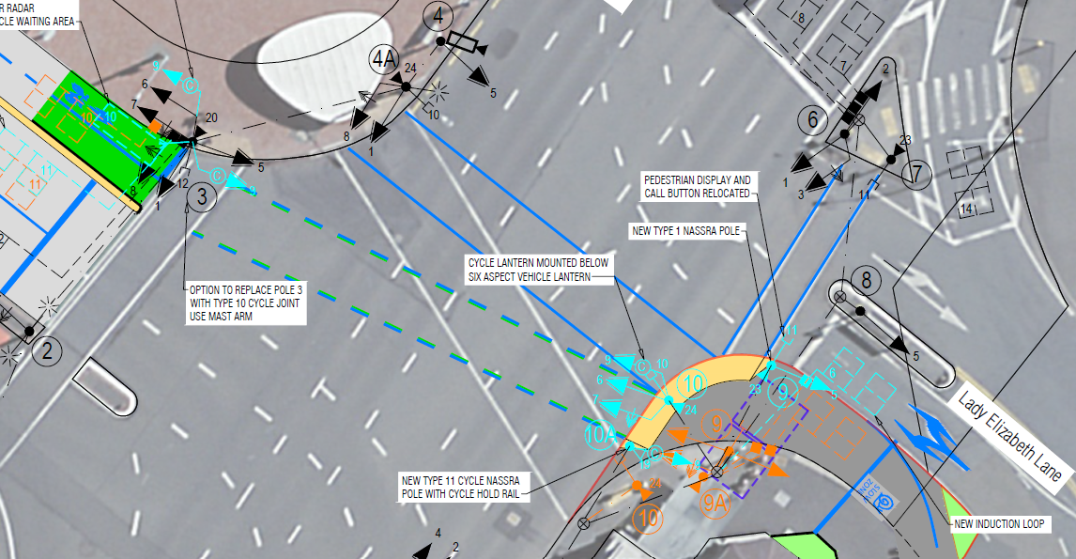  Figure 3-16: Diverging crossings from Lady Elizabeth Lane side |  | Probability of crash occurring |  | Unlikely
 |  | Expected crash severity |  | Minor injury
 |  | Primary treatment recommendations:
 |  |  | N/A
 |  | Supporting treatment recommendations:
 |  |  | Mark the cycle crossing waiting area with green paint/tactiles and cycle symbols.
 |  |  | Mark the pedestrian crossing waiting area with yellow tactiles and pedestrian symbols.
Responses:
Designer | Agree with recommendations.
Safety Engineer | Agree with Designer response.
Client | Agree with responses.
Action | Addressed in final Developed Designs.

Audit statement
We certify that we have used the available plans and have examined the specified roads and their environment to identify features of the project we have been asked to look at that could be modified or removed to improve safety. The safety issues identified in this report are summarised in Table 4-1.
Table 4-1: Summary of Issues
Serious | Significant |  | Moderate | Minor |  | Comments |  | Total
1 | 6 |  | 1 | 5 |  | 5 |  | 18
Number | Safety issue |  |  |  |  |  |  | Ranking
3.1 | Bunny Street / Featherston Street / Thorndon Quay intersection
3.1.1 | Potential for cyclists to enter intersection at the wrong time |  |  |  |  |  |  | Serious
3.1.2 | Unintuitive positioning of primary cycle signals on Bunny Street cycleway approach |  |  |  |  |  |  | Significant
3.1.3 | Unintuitive positioning of far-side cycle signals |  |  |  |  |  |  | Significant
3.1.4 | Ambiguity of Bunny Street cycleway bend approach right-turn arrow marking |  |  |  |  |  |  | Significant
3.1.5 | Disruptions to provision for cycleway bend from Bunny Street (movement C4) |  |  |  |  |  |  | Minor
3.1.6 | Missing phase for cycleway bend from Thorndon Quay (movement C2) |  |  |  |  |  |  | Comment
3.1.7 | Plans missing signal group numbers for Bunny Street cycleway primary cycle signals |  |  |  |  |  |  | Comment
3.1.8 | Uncertainty regarding turning vehicle tracking conflicts between Thorndon Quay and Bunny Street |  |  |  |  |  |  | Comment
3.2 | Bunny Street midblock
3.2.1 | Appropriateness of raised platform |  |  |  |  |  |  | Comment
3.2.2 | Pedestrian-cycle conflict at Bunny Street midblock pedestrian crossing |  |  |  |  |  |  | Minor
3.2.3 | Westbound on-road cyclist access to cycleway |  |  |  |  |  |  | Significant
3.2.4 | Tight turn into general traffic left turn / through approach lane on Bunny Street east approach |  |  |  |  |  |  | Minor
3.2.5 | Lack of physical separation on cycleway approaching pedestrian crossing |  |  |  |  |  |  | Minor
3.2.6 | Unintended turning into taxi loop exit |  |  |  |  |  |  | Moderate
3.2.7 | Speed calming device on wrong side of cycleway at taxi loop exit |  |  |  |  |  |  | Significant
3.3 | Bunny Street / Waterloo Quay / Lady Elizabeth Lane intersection
3.3.1 | Likely reduced capacity of Lady Elizabeth Lane approach |  |  |  |  |  |  | Comment
3.3.2 | Protection for pedestrians crossing Bunny Street |  |  |  |  |  |  | Significant
3.3.3 | Potential for pedestrians and cyclists to confuse crossings on Lady Elizabeth side |  |  |  |  |  |  | Minor
Designer: |  | Sam Thornton |  |  | Position |  | Technical Principal - Transportation
Signature |  |  |  |  | Date |  | 08/09/2025
Safety Engineer: |  | Soon Teck Kong |  |  | Position |  | Engineering and Operations Manager
Signature |  | 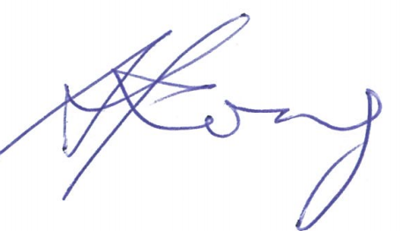 |  |  | Date |  | 4 Feb 2026
Project Manager: |  | Nicola Mitchell |  |  | Position |  | Project Manager CCBC
Signature |  |  |  |  | Date |  | 4 Feb 2026
Asset Owner: |  | Ross Balfour |  |  | Position |  | Manager Transport Infrastructure and Operations
Signature |  |  |  |  | Date |  | 5/02/2026

Identification of safety concerns
The identification of safety concerns is more akin to the traditional road safety audit, undertaken according to safe systems principles. Each issue is assessed in terms of the probability of a crash arising, the expected severity of that crash type, and the resulting crash risk rating. Recommendations to address this are provided.

Crash probability
The probability of a crash is qualitatively assessed based on expected exposure (how many road users will be exposed to the site) and the likelihood of a crash resulting from the presence of the specific safety issue. Probability ranges from “very likely” to “very unlikely” and have been based on the categories in the Austroads Guide to Road Safety part 6: Road Safety Audit (2022) but adapted for the 4-tier probability structure used in the guide by NZ Transport Agency Waka Kotahi (NZTA) 2022.
Table 4-2: Relationship between crash probability and frequency
Probability of a crash occurring | Frequency of crashes expected
Very likely | One crash every 3 months (4+ crashes / year)
Likely | One crash every 3-12 months (1-4 crashes / year)
Unlikely | One crash every 1-7 years (0.1-1 crashes / year)
Very unlikely | One crash every 7+ years (<0.1 crashes / year)

Crash severity
The expected severity outcome of a crash is qualitatively assessed based on factors such as expected speeds, type of collision, and type of user/vehicle/object involved.
Table 4-3 is based on Austroads Guide to Road Safety part 6: Road Safety Audit (2022) but in colour instead of greyscale, gives an indication of the expected crash severity based on these factors.
Table 4-3: Expected crash severity by crash type and crash speed (adapted from Austroads GRS6, 2002)
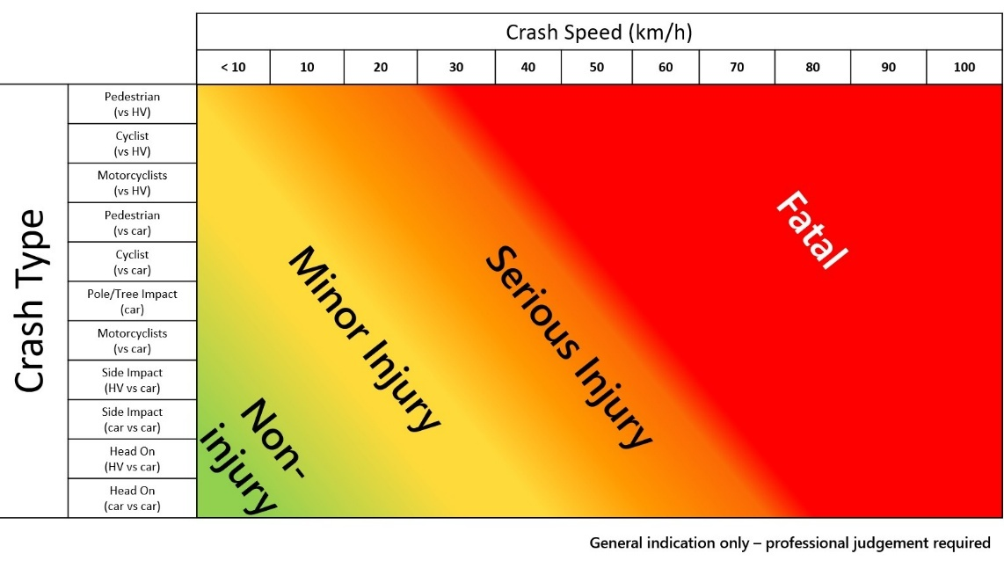

Table 4-4 describes the four crash severities used.
Table 4-4: Crash severity descriptions adapted from NZ Transport Agency Waka Kotahi (NZTA) Safe Systems Audit Guidelines, 2022
Severity outcome | Description
Fatal | Where Safe System boundary conditions are exceeded.  A death occurring as the result of injuries sustained in a road crash within 30 days of the crash.
Serious | Where Safe System boundary conditions are exceeded.  Injury (fracture, concussion, severe cuts or other injury) requiring medical treatment or removal to and retention in hospital.
Minor | Where Safe System boundary conditions are met.  Injury that is not ‘serious’ but requires first aid, or that causes discomfort or pain to the person injured.
Non-injury | Where Safe System boundary conditions are met.  Property damage crashes.
Reference to historic crash data or other research for similar elements of projects, or projects as a whole, have been drawn on where appropriate to assist in understanding the likely crash types, probability and severity that may result from a particular concern.

Crash risk rating
The probability and severity ratings are used together to develop a combined qualitative risk ranking for each safety issue using the NZ Transport Agency Waka Kotahi (NZTA) Safety Concern Risk Rating Matrix shown in Table 4-5. The qualitative assessment requires professional judgement and experience from a wide range of projects of varying sizes and locations.
Table 4-5: Safety concern risk rating matrix from the NZ Transport Agency Waka Kotahi (NZTA) Safe Systems Audit Guidelines, 2022.
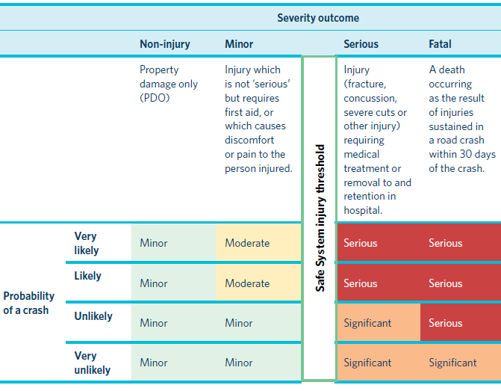
While all safety concerns should be considered for action, the client will make the decision as to what action will be adopted. This report gives safety ranking guidance, and it is acknowledged the client must consider factors other than safety alone. The suggested action for each concern category is given in Table 4-6.
Table 4-6: Concern categories
Risk | Suggested Action
Serious | Serious safety concern that must be addressed and requires changes to avoid serious injury consequences.
Significant | Significant safety concern that should be addressed and requires changes to avoid serious injury consequences.
Moderate | Moderate safety concern that should be addressed to improve safety
Minor | Minor safety concern that should be addressed where practical to improve safety.
In addition to the ranked safety issues, it is appropriate for the SAT to provide additional comments such as:
- items where the safety implications are not yet clear due to insufficient detail for the stage of project;
- items outside the scope of the audit such as existing issues not impacted by the project;
- an opportunity for improved safety that is not necessarily linked to the project itself, or
- drawing/signage issues that should be addressed but are not necessarily safety related.
While typically comments do not require a specific recommendation, in some instances suggestions may be given by the SAT.

Recommendations
Each issue is accompanied by a list of recommendations to address the issue. As per the safe systems framework, these are classified as relating to either:
- Primary treatments – i.e. those capable of virtually eliminating death or serious injury resulting from the specific safety issue; or
- Supporting treatments – reduce the overall harm caused by the safety issue.

