Kia ora,

We would like to inform you about a proposed change in your neighbourhood.

Proposal:

Reference | - TR30-26 Bunny Street Connection, Wellington – Proposed pedestrian improvements, cycleway and parking changes
Location – where we propose to make the change | Bunny Street, Lady Elizabeth Lane northern end
What we’d like to do | - Install a midblock raised platform on Bunny Street to provide a clearer place for people to cross to and from Wellington Station and improve safety.  - Install a separated bi-directional cycleway on the northern side of Bunny Street, from Featherston Street to Waterloo Quay.  - Remove six P120 metered parking spaces on the northern side of Bunny Street.  - Make the western section of Bunny Street between Lambton Quay and Featherston St one way for vehicles for the full length from Featherston St to Lambton Quay with a two-way flow for cycles for this section of Bunny Street. To exit this section of Bunny Street cars will need to use the Lambton Quay end.  - Install a 42metres cycle lane on the southern side of Lady Elizabeth Lane, at the Waterloo Quay intersection.  - Reduce the number of turning lanes on Bunny Street at Waterloo Quay from 3 turning lanes (two right turning and one left turning) to 2 turning lanes (one right turning and the other a shared right and left turning lane).  - Shorten the Coach stop by 7.5metres to provide better visibility of the midblock crossing area.
Why we are proposing the change | - Wellington City Council is focussed on providing more transportation options in and around the city centre, including walking, cycling and public transport.  - The Council has now completed cycling routes into the CBD from the south, north and west and the Evans Bay route from the east is due for completion in 2026. As a result, over the coming years we can expect to see an increase in the numbers of people cycling into and around the city.  - In addition, the regional connection from the Hutt Valley into Wellington City (Te Ara Tupua) is now complete. This is expected to double the number of people coming into town by bike from the Hutt Valley in the first year and more than triple by 2030.  - With an increase in the number of people cycling into Wellington City, this project is required to manage the increased demand and connect the Thorndon Quay cycleway to the waterfront so that people cycling and scooting can more easily and safely access the waterfront and central city destinations.  - We are also looking to improve safety and accessibility for the many pedestrians that come and go from Wellington Station every day by providing a safer raised crossing facility in the mid-block. Raising the crossing facility also helps to reduce traffic speeds in this pedestrian space which is busy during commuter peak periods.  - Bunny Street has had 61 crashes in the last ten years, including 10 involving cyclists (1 serious, 3 Minor, and 6 non-injury) and 6 involving pedestrians. This is a lot for a short stretch of road.  - Bunny Street is part of Paneke Pōneke, Wellington’s plan for a citywide bike network, which was approved by the Council in March 2022.  - Implementing these street changes will support the strategic goals outlined in the Long-term Plan, the Regional Land Transport Plan and Te Atakura by increasing travel options, improving safety, supporting growth, and enabling a reduction in transport-generated carbon emissions.
Impact | Net Parking impact  - Removal of six metered parking spaces on the northern side of Bunny Street.  Pedestrian Impact  - Improved safety, accessibility, visibility and coherence for pedestrians with a raised platform across the middle of Bunny Street.  - Reduced conflicts between pedestrians, people on bikes and scooters on the footpath in Bunny Street.  - Improved crossing facilities for pedestrians to and from the Station with raised platforms to slow vehicle speed and kerb extensions will narrow the crossing distance.  - Increased pedestrian space on the Lady Elizabeth Lane side of the Waterloo Quay crossing to improve visibility at the pinch point at the building corner  - Increased crossing distance at the Featherston Street end of Bunny Street  Cycling impact  - Improves safety and coherence for people on bikes travelling east and west along Bunny St between Waterloo Quay and Featherston Street  - Delivers a key link in the Wellington bike network, connecting the route from the north to the waterfront space preparing for the expected increase in cycle traffic after the opening of the Te Ara Tupua shared path.  - Improves coherence of crossing point in both directions for bikes across Waterloo Quay  - Improves the level of service for cyclists at the Thorndon Quay/ Bunny Street intersection with turning and straight through lanes  Driver impact  - Drivers will slow down on approach to the raised crossing facility  - Drivers (including taxis and ubers) will slow down to enter and exit the station pickup and drop off area at the raised platforms and check for bikes  - Changes in lane configuration on Bunny Street at Waterloo Quay intersection may mean drivers would choose a different route to the Quays or experience additional queuing and delays.  - There will be six less roadside car parks on Bunny Street however the preferred option retains parking on the southern side of the road next to the businesses where there are carparks, a loading zone and a coach stop.
Other options considered | Bunny Street  Option 1: Full length shared path on the footpath along the north side of Bunny Street, from the intersection with Featherston Street to the intersection with Waterloo Quay.  - This option is not preferred as it creates too much conflict between people walking, cycling and scooting in different directions along and across this street.  Option 2: Separated unidirectional cycleway on both sides of Bunny Street.  - This option is not preferred as it removes parking on both sides of the street and introduces more complex crossing movements at intersections.  Whitmore Street  This corridor was considered initially but it does not provide a coherent and safe route north to Thorndon Quay for people on bikes. It provides a better east west connection to and from the Terrace and Karori than it does a connection to the north
How this relates to the parking policy | - As outlined in the Parking Policy 2020, the safe and efficient movement of people and goods, including footpaths and cycleways, has been prioritised over short-term parking.  - These changes have been designed to facilitate a shift to using active transport (e.g. walking and cycling) through parking management and the reallocation of road space.
Additional Information | - Average daily traffic count:  - Bunny Street eastbound 3278 and Bunny St westbound 2603  - Waterloo Quay northbound 12464, Waterloo Quay southbound 13,020. (Daily average, month of May, 2026)  - Average daily cycle count – Bunny Street – 583 (Daily average, month of May, 2026)  - Annual parking revenue impact – loss of $46,955  - Bunny Street has had 61 crashes in the last ten years, including 10 involving cyclists (1 serious, 3 Minor, and 6 non-injury) and 6 involving pedestrians.  - To view the legal description for this Traffic Resolution, an electronic copy of the report will be available on the Council’s website from 9.00am Monday 13 July 2026 at https://www. transportprojects.org.nz/bunnyst
Privacy | - Your privacy is important to us. Please DO NOT add specific personal details to your feedback (i.e.: full name, address, etc)  - What we do with your personal information:  All submissions (including your first name, but not contact details) are provided in their entirety to elected members and made available to the public on our website and at our office. Personal information (including contact details) will also be used for the administration of the consultation process including informing you of the outcome of the consultation. All information collected will be held by Wellington City Council, 113 The Terrace, Wellington, with submitters having the right to access and correct personal information.  - For more information regarding our Privacy Statement please check our webpage: Privacy statement - Wellington City Council.
Feedback | - If you would like to provide us with specific feedback, which will be added to the Traffic Resolution following consultation and made public in full, you can do so by filling out an online submission form, downloading a printable submission form on https://www. transportprojects.org.nz/bunnyst or emailing us at citydesignprojects@wcc.govt.nz.  Please note if you are giving feedback the consultation period opens at 9.00am, July 13, 2026, and finishes at 5.00pm, August 3, 2026.
Next Steps | - Feedback collated by end of August.  - The proposal will go to the Te Takere|Regulatory Processes Regulatory Processes Committee meeting on 7 Oct 2026.  - If approved, the proposal will commence installation within the following four months.

Traffic Resolution Plan: TR30-26 Bunny Street Connection, Wellington – Proposed pedestrian improvements, cycleway and parking changes

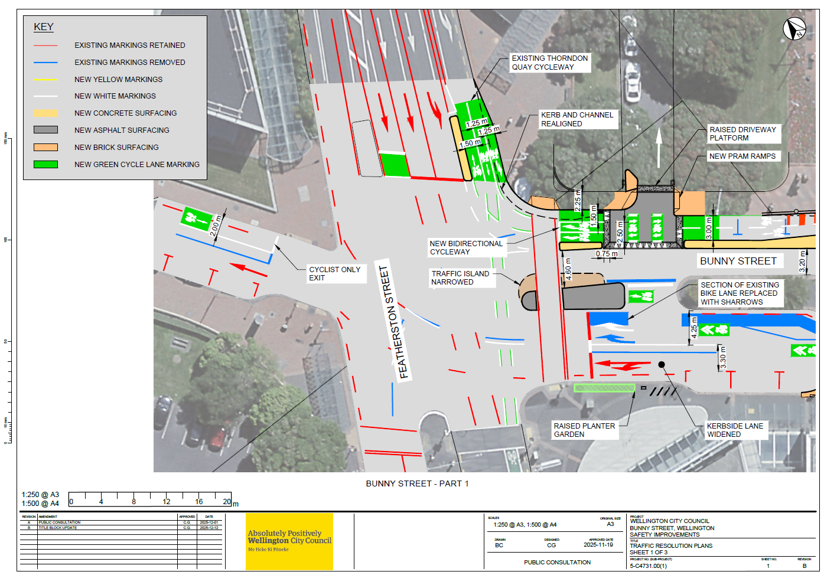

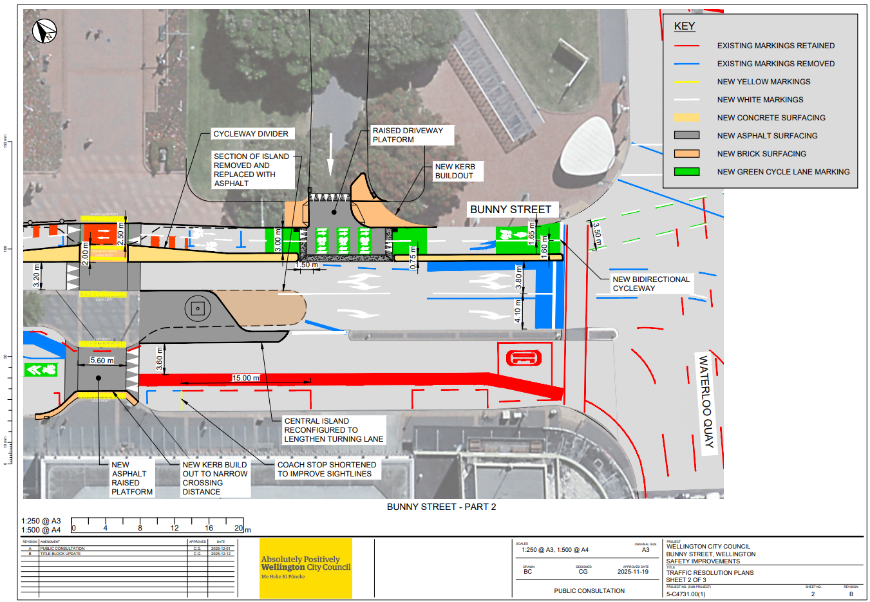
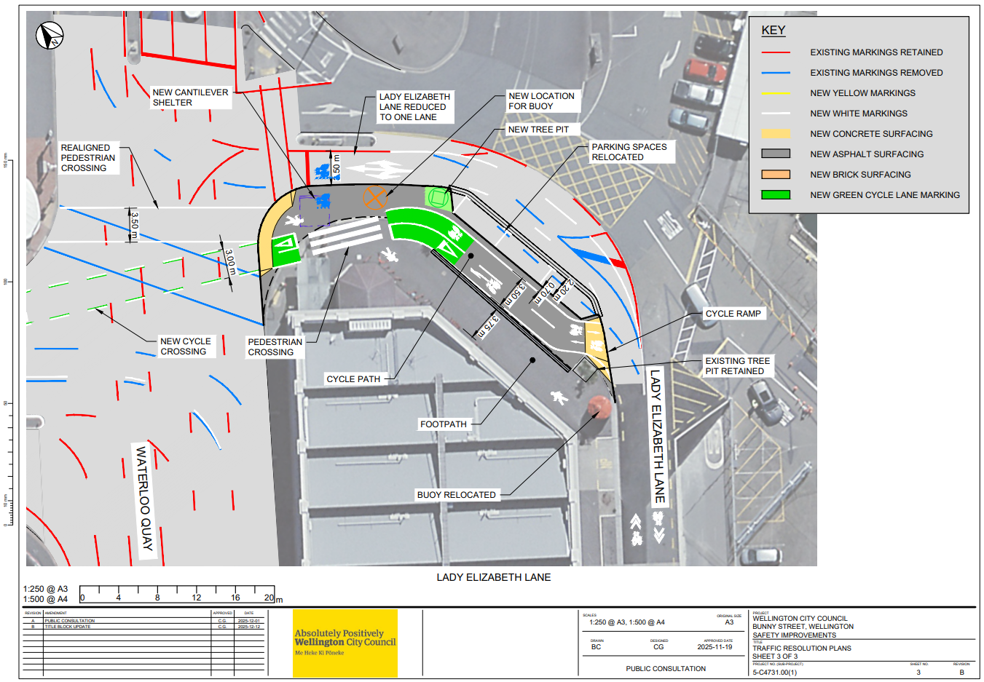
Legal Description:

Delete from Schedule B (Class Restricted) of the Traffic Restrictions Schedule

Column One | Column Two | Column Three
Bunny Street | Coach Stop, At All Times | Southwest side, commencing 34 metres northwest of its intersection with Waterloo Quay (Grid Coordinates X=2659106.043866 m, Y=5990312.494717 m) and extending in a north-westerly direction following the southwest kerbline for 22.5 metres.

Delete from Schedule C (Turning and One Way Restrictions) of the Traffic Restrictions Schedule

Column One | Column Two | Column Three
Bunny Street | One Way Restriction, except cycles at all times | Commencing 35 metres northwest of its intersection with Featherston Street/Stout Street (Grid coordinates x= 1748997.9 m, y= 5428682.8 m), and extending in a north-westerly direction for 62.5 metres.

Delete from Schedule F (Metered Parking) of the Traffic Restrictions Schedule

Column One | Column Two | Column Three
Bunny Street | P120 Maximum, Monday to Thursday 8:00am - 6:00pm, Friday 8:00am - 8:00pm, Saturday and Sunday 8:00 - 6:00pm | Northeast side, commencing 22.5 metres southeast of its intersection with Featherston Street (Grid coordinates x= 1749013.9 m, y= 5428682.3 m), and extending in a south-easterly direction following the north-eastern kerb line for 17 metres. (3 parallel carparks)
Bunny Street | P120 Maximum, Monday to Thursday 8:00am - 6:00pm, Friday 8:00am - 8:00pm, Saturday and Sunday 8:00 - 6:00pm | Northeast side, commencing 50 metres southeast of its intersection with Featherston Street (Grid coordinates x= 1749013.9 m, y= 5428682.3 m), and extending in a south-easterly direction following the north-eastern kerb line for 17 metres. (3 parallel carparks)

Add to Schedule B (Class Restricted) of the Traffic Restrictions Schedule

Column One | Column Two | Column Three
Bunny Street | Coach stop, at all times | Southwest side, commencing 38 metres northwest of its intersection with Waterloo Quay (Grid coordinates x= 1749084.3 m, y= 5428600.3 m) and extending in a north-westerly direction following the southwestern kerbline for 15 metres.

Add to Schedule C (Turning and One Way Restrictions) of the Traffic Restrictions Schedule

Column One | Column Two | Column Three
Bunny Street | One Way Restriction, except cycles at all times | Westbound from Featherston Street to Lambton Quay

Add to Schedule I (Cycleway) of the Traffic Restrictions Schedule

Column One | Column Two | Column Three
Lady Elizabeth Lane | Bi-directional Cycle lane, at all times | South side, commencing at the intersection with Waterloo Quay (Grid coordinates x= 1749119.8m, y= 5428613.4m) and extending in a south-easterly direction following the southern kerb line for 42.0 metres.
Bunny Street | Bi-directional Cycle lane, at all times | North side, commencing at its intersection with Waterloo Quay (Grid coordinates x= 1749084.3 m, y= 5428600.3 m) and extending in a westerly direction following the northern kerb line for 96.5 metres

Prepared By: | Nicola Mitchell | Project Manager – Cross City Bike Connections
Reviewed By: | Kate Gourdie | TL Traffic & Resolutions
Approved By: | Ross Balfour | Manager Transport Infrastructure and Operations
Approved Date: | 08/06/2026

